

ITA_User instruction Manual

Menu creation function

*－*Version 1.6*－*

Copyright © NEC Corporation 2020. All rights reserved.

Disclaimer

All the contents of this document are protected by copyright owned by NEC Corporation.

Unauthorized reproduction or copying of all or part of the contents of this document is prohibited.

The contents of this document are subject to change without prior notice in the future.

NEC Corporation is not responsible for any technical or editorial errors or omissions in this document.

NEC Corporation do not guarantee accuracy, usability, certainty of the content in this document.

Trademark

* Linux is registered trademark or trademark of　Linus Torvalds, registered in the U.S. and other countries.
* Red Hat is registered trademark or trademark of Red Hat, Inc. registered in the U.S. and other countries.
* Apache, Apache Tomcat, and Tomcat are registered trademarks or trademarks of the Apache Software Foundation.
* Ansible is registered trademark or trademark of Red Hat, Inc.

The names of other systems, company name and products mentioned in this document are registered trademarks or trademarks of their respective companies.

The ® mark and TM mark are not specified in this document.

※「Exastro IT Automation」 is written as 「ITA」 in this document.

**Table of contents­­**

Introduction 3

1 Overview of menu creation function. 4

2 Main functions of menu creation function 7

3 Menu group of menu creation function 8

4 Menu (Parameter sheet/Data sheet) Description 10

5 Operation description of (Define/Create Menu) menu 13

5.1 (A) Setting of Item/Group/Repeat 13

5.2 (B) Menu creation information tab 18

5.3 (C) Execute menu creation 21

5.4 Usage of 「Define/Create Menu」after menu creation 22

5.5 Check created menu in「Menu definition information」 24

5.6 Check the status of creation using「Menu creation history」 27

5.7 Check the created menu 28

6 Hidden menus of 「Create Menu」menu group 44

6.1 Register a column group using 「Column group list」 44

6.2 Register items to be set using「Menu item creation information」 46

6.3 Vertical registration using「Vertical menu creation information」 50

6.4 Create parameter sheet/data sheet using「Create menu」 52

7 Applicational operation 54

7.1 Maintenance 54

7.2 Change log level 55

8 Appendix 56

8.1 Placing PHP files 56

8.2 Menu / Table link list 57

8.3 Other menu link 58

8.4 Menu conversion information 59

8.5 Trace history when「Pulldown selection」is included in the sheet 60

# Introduction

This document describes the functions and operation methods of the ITA menu creation function (here after referred to as menu creation) system.

# Overview of menu creation function.

The menu creation functions is for creating menus that can be operated on ITA.

The number of items, format, size and input restrictions of menus (parameter sheets/data sheets) can be freely designed with the menu creation function.

You can freely design the number, format, size, and input limit of menu (parameter sheet/data sheet) items.

The menu types users can create include parameter sheets and data sheets.

1. Parameter Sheet

* Manage IaC variable values
* This menu can be set with the function 「Substitution value auto registration setting」 of each driver.
* "Menu creation" menu group > "Create/define menu" menu> "Menu creation information" tab> "Basic information" frame> In the "Creation target" item, the menu created by selecting "Parameter sheet (with operation)" and "Parameter sheet (with host/operation)" is called a parameter sheet.
* By setting the target parameter sheet and IaC variable in the "Substitution value automatic registration setting" menu of each driver, it is possible to automatically substitute the value entered in the "Parameter" field of the parameter sheet to the IaC variable.
* With operation

Parameter sheets are created in "Operation" units.

* With host/operation

Parameter sheets are created in "host/Operation" units.

* Create as host group menu

It is possible to manage IaC values for host groups by linking with "Host Group Function".

* Using vertical menus

When configuring parameters that repeats the same item, users can use a vertical menu for better visibility.

1. Data Sheet

* Data management within ITA
* It is possible to create a data sheet where users can freely create items. Data sheets cannot be used in the "Substitution value automatic registration setting" menus.
* It can be used as a CMDB (Configuration Management Database) to manage the information on the ITA.
* By using it as a reference for items that can be selected in pull-down from other menus, it is possible to avoid wording inconsistencies.

Example) Parameter sheet (with host/operation)

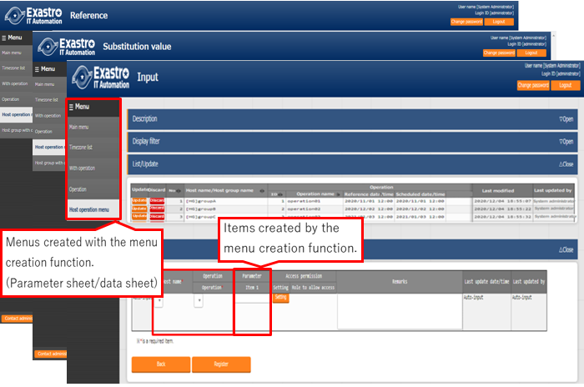

**Figure 1-1 parameter sheet**

Example) Data sheet

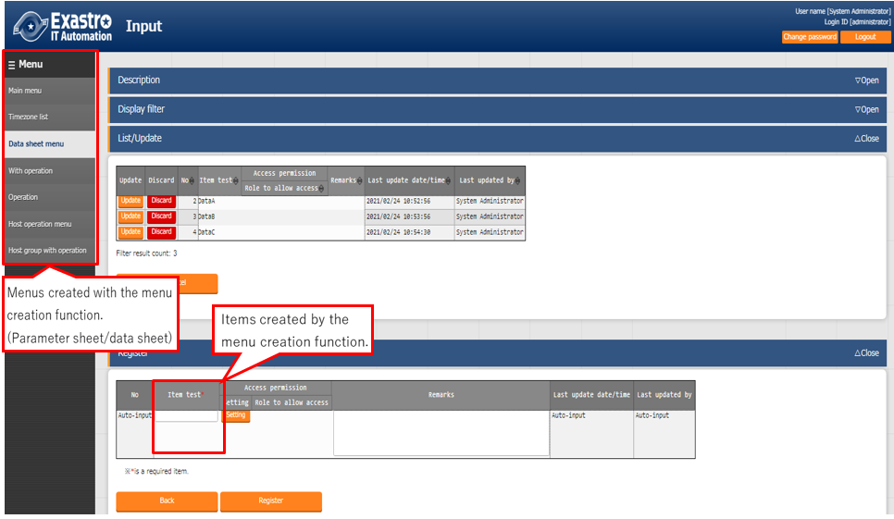

**Figure 1-2 data sheet**

Example) How to use a datasheet as a "Reference pulldown"

By selecting the input value in pull-down format, it is possible to prevent wording inconsistencies from manual input.

・Create a datasheet as a "Reference pulldown". 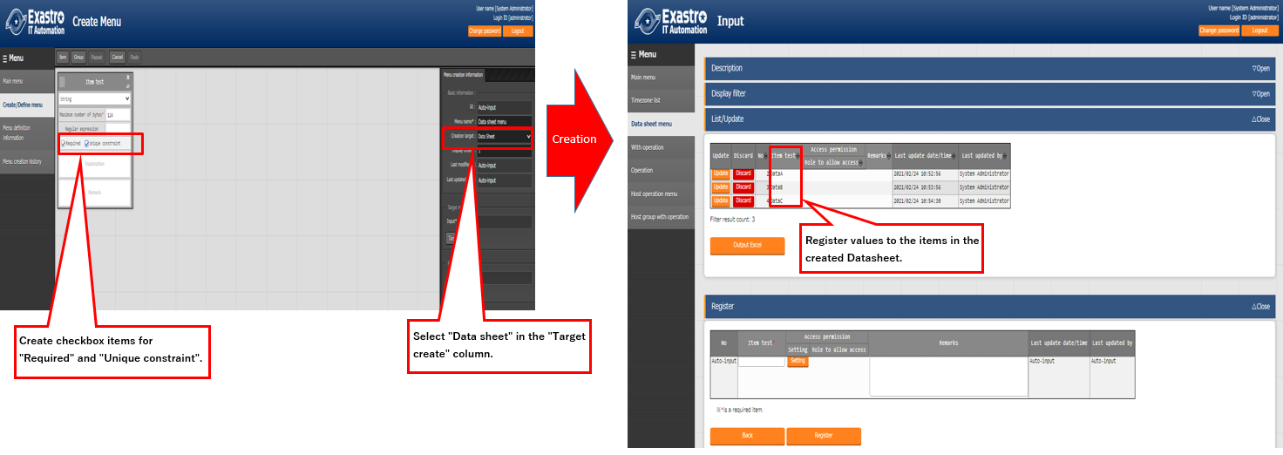

**Figure 1-3 Data sheet as reference**

・Specify "Pull-down selection" as the input method and create a menu (parameter sheet/data sheet).

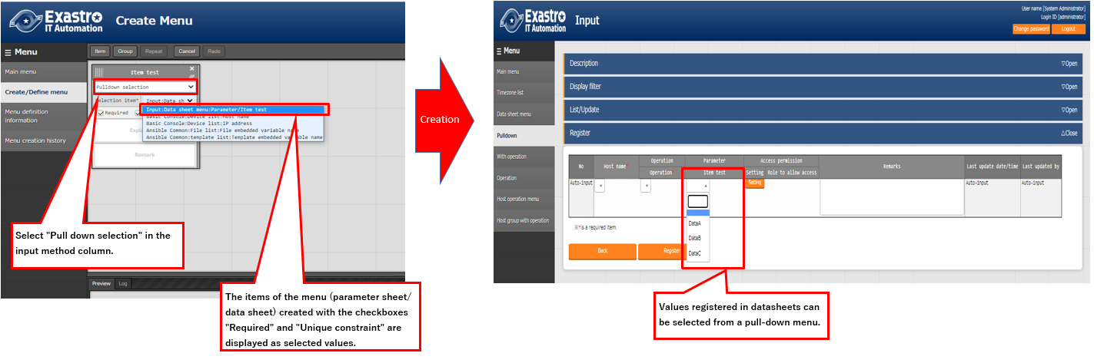

**Figure 1-4 Parameter sheet referring to the registration value of the data sheet in the pull-down menu**

# Main functions of menu creation function

The main functions of the parameter sheet creation function are classified into the following categories.

* Web  
  Web contents. A screen that allows users to use the function of creating a parameter sheet provided in the browser.
* BackYard  
  A resident process that runs on a server independently from Web content.

# Menu group of menu creation function

The menu group of the menu creation function and the menu that belongs to it are as follows.

* When menu (parameter sheet / data sheet) is created in the "Menu Definition/Create" menu, data is automatically registered in each menu of "Menu definition list", "Column group management", "Menu item creation information" and "Menu (vertical) creation information", so there is no need to create data within each menu.

In addition, since the menu (parameter sheet/data sheet) is created automatically, so there is no need to create and execute it in the "Menu creation execution" menu.

* If you want to use a hidden menu, please revive the target menu in "Role/menu link list".

(Please, refer to the “Exastro-ITA_User_Manual_Management Console” for revival/abolition instructions.)

**Table 3-1 Menus that belongs to the "Create menu" menu group**

|  |  |  |  |
| --- | --- | --- | --- |
| **Menu**  **group** | **Menu** | **Section** | **Description** |
| Create menu | Create/Define menu | **5.1~5.4** | Create/update parameter sheet or datasheet |
| Menu definition information | **5.5** | The menu names of the parameter sheet or datasheet to be created can be maintained (View/Update/Discard/Restore). |
| Menu creation history | **5.6** | Users can check the status of menu creation |
| Column Group list | **6.1** | The column groups of the parameter sheet or datasheet to be created can be maintained (View/Update/Discard/Restore).  ※This menu is hidden after installation. |
| Menu item creation information | **6.2** | The items of the parameter sheet or datasheet to be created can be maintained (View/Update/Discard/Restore)  ※This menu is hidden after installation. |
| Vertical Menu creation information | **6.3** | Select the menu name and start item name of the parameter sheet or data sheet to be created, and specify the number of items in vertical management display and number of repetitions.  ※This menu is hidden after installation. |
| Create menu | **6.4** | Create the menu of the parameter sheet or data sheet in the menugroup that is specified in 「Menu creation information」 menu.  ※This menu is hidden after installation. |
| Menu / table link list | **8.2** | Displays the link between the created menu and the DB table  ※This menu is hidden after installation. |
| Other menu link | **8.3** | Displays the link / association between menu group, menu, item, and DB table of created menu  ※This menu is hidden after installation. |
| Menu conversion information | **8.4** | Displays the link of the menu that is horizontal from vertical menu.  ※This menu is hidden after installation. |

※In the "Create/Definition menu" menu, it is possible to maintain menus (parameter sheets/data sheets) one at a time. However, if you want to maintain multiple menus (Parameter sheets/Data sheets) at the same time, you have to do so from Excel.

# Menu (Parameter sheet/Data sheet) Description

* Types of sheets can be created.

When initiation a creation of a menu where "Parameter sheet" ("Menu creation" menu group-> "Menu definition/creation" Menu-> "Menu creation information" tab->"Creation Target" field") is selected, a menu (Parameter sheet) that allows users to set items in the " Substitution value automatic registration setting" menu of each driver will be created.  
If 「Data Sheet」 is selected as the creation target and menu creation is executed, a Data Sheet that is not available in 「Substitute value auto registration setting」will be created.

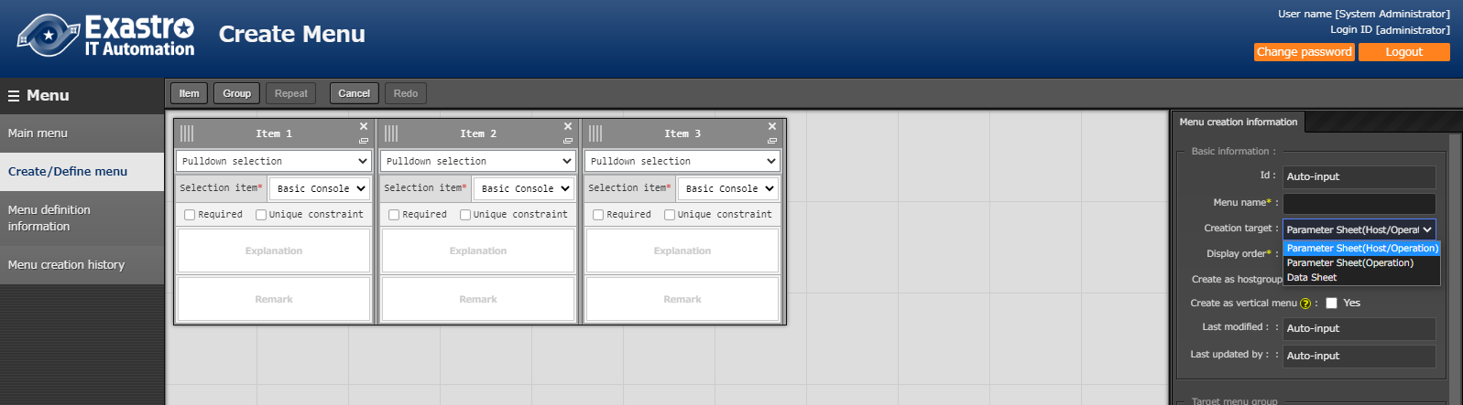

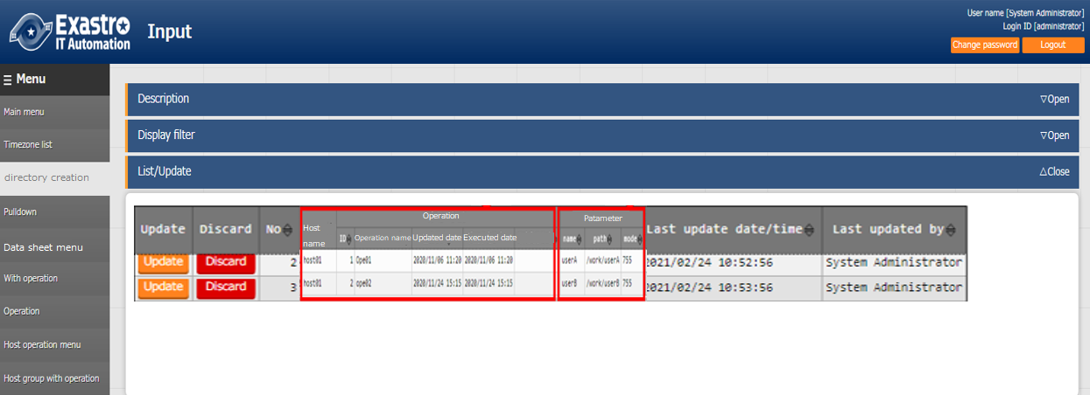 **Figure 4-1 "Target create" column**

A "Parameter" item that can be set in the "Substitution value automatic registration setting" menu will be created.

If "Creation target" is used as a parameter sheet, "Host operation" or "Operation item" will be automatically granted.

**Figure 4-2 Menu created with "Parameter sheet" (In the target column (Parameter sheet)) selected.**

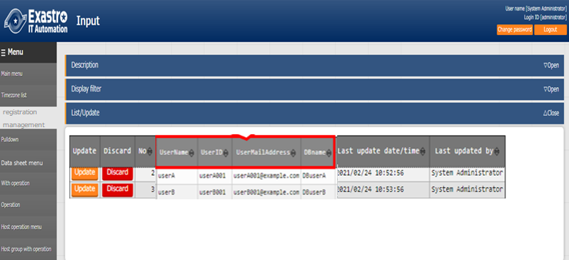

If "Creation target" is used as a "Data sheet", users can create items freely.

**Figure 4-3 Menu created with "Data sheet" (In the target column (Data sheet)) selected.**

Comparison between parameter sheets and data sheets.

|  |  |  |  |
| --- | --- | --- | --- |
| Selected value of Creation target | Substitute value auto registration setting | Menu items | Relationship with host/operation |
| “Parameter Sheet” | Configurable | 「Host」 and 「Operation」 items are automatically added. Other items can be created freely. | Associated with specific host/operation. |
| “Data Sheet” | Not configurable | All items can be created freely. | Not associated with specific host/operation |

**Table 4-1 Comparison of menus (parameter sheet/data sheet)**

※The Data Sheet is intended to be used as a source of reference for items selected by pulldown from other menus, and to be used as a CMDB（Configuration Management Database） for centralized management of data on ITA.

* Menu creation pattern

The five menu creation patterns that can be created with the menu creation function are shown below.

1. Parameter sheet selection & with "host group" & With "vertical menu"
2. Parameter sheet selection & with “host group”
3. Parameter sheet selection & with “vertical menu”
4. Parameter sheet selection
5. Data sheet selection

If Parameter sheet is selected, a menu (Parameter sheet) will be created for the 3 menu groups.

1. For input
2. For substitution value automatic registration
3. For reference

If Data sheet is selected, a menu (Data sheet) will be created for the 1 menu groups.

1. For input

Menu (Parameter sheet/Data sheet) maintenance (register/update/abolition/revival) operations can only be performed on the "A) For input” menu group.

Register/update/abolition/revival cannot be performed in other menu groups.

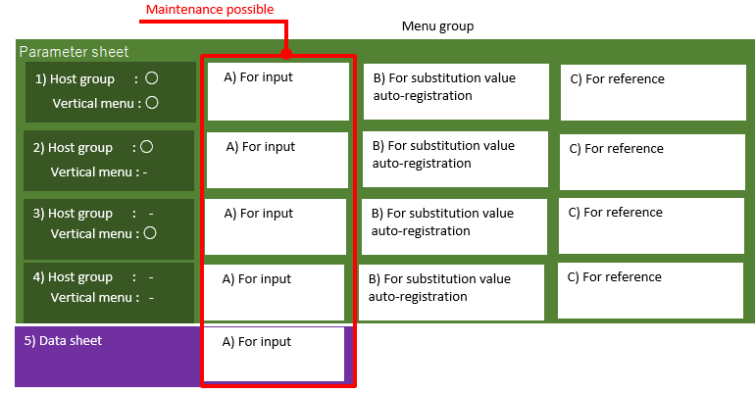

**Figure 4-4 menu creation pattern**

・Create as host group menu

When grouping the target hosts by using the host group function, it is recommended to use the host group.

Please refer to 「User instruction Manual_Host Group Function」 for the Host group function.

・Create as host group menu

For example, when define the same item repeatedly, such as "IP address" + "domain" in the hosts file, we recommend using the vertical menu for better visibility. If you do not need to enumerate a fixed number of items repeatedly like the kernel parameters, we recommend that you do not use the 「Vertical menu」 and use the normal menu.

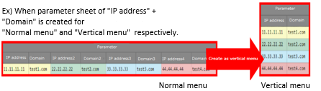

Vertical menu

**Figure 4-5 Comparison of “Normal menu” and “Vertical menu”**

# Operation description of (Define/Create Menu) menu

Menu creation and parameter sheet/data sheet definition are performed in “Define/Create Menu” screen.

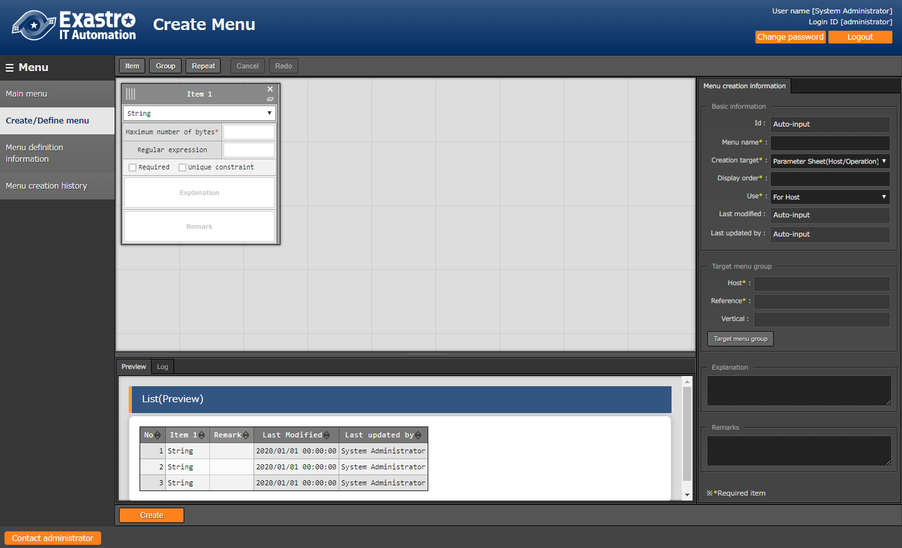

B

A

C

**Figure 5.1 “Create/define menu” menu**

## (A) Setting of Item/Group/Repeat

Set the items for menu (parameter sheet/data sheet)

* Item button

Click “Item” button to add new item and set it.

It is possible to add it as an item to the menu (parameter sheet/data sheet) by selecting the input method from the pull-down menu and entering the required items.

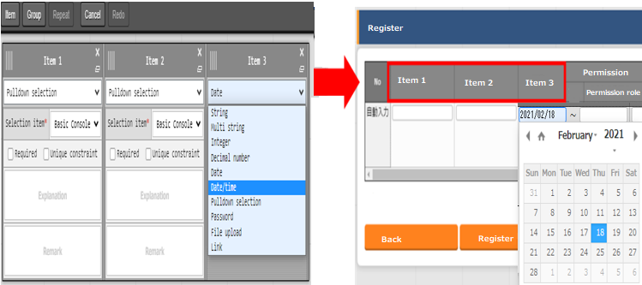

**Figure 5.1-1 Item creation**

**Table 5.1-1 setting item value**

| **Item name** | | **Description** |
| --- | --- | --- |
| Item name  (Item 1 is set on default) | | Enter the item name to be displayed on the menu  .※ Do not use 「/」 in the item names. When 「/」 is used, the  「Substitute value auto registration setting」 in each driver may not work properly. |
| Pulldown menu  (Input method) | | Selecte “String”, “Multi string”, “Integer”, “Decimal number”, “Date”, “Date/time”, “Pull down selection” from the pulldown menu.  When “String” is selected, the item is a text box with single line input.  When “Multi string” is selected, the item is a text box with multiple line input.  When “Integer” is selected, the item is a text box that only integer can be entered.  When “Decimal number” is selected, the item is a text box that integer/decimal number can be entered.  When “Date” and “Date/time” is selected, the item is entered by calendar selection.  When “Pulldown selection” is selected, the item is a pulldown menu item.  If "Password" is selected, the item will be a text box where any text typed in the box will be hidden with "●”( The text will only be displayed if the eye icon inside the frame is pressed)  When "File upload" is selected, the item will contain 2 buttons. One where users can browse and select files, and one called "Pre-upload".  When "Link" is selected, the entered URL will be a text box item that will be displayed as a link.  ※ About the trace history of the menu created with 「Pulldown selection」 is selected, the supplement is described in 「8.5 Trace history when「Pulldown selection」is included in the sheet」.  ※The association target item in “Substitution value automatic registration setting” are “String”, “Multi string”, “Integer”, and “Decimal number”. “Date/time”, and “Date” can’t be associated. “Pulldown selection” can’t be associated if the item of pulldown selection are “Multi string”, “Date/time”, and “Date”. |
| String | Maximum number of bytes | Enter the maximum number of bytes.  The maximum size is 8192 bytes.  The byte count of half-width alphanumeric characters are equivalent to the number of characters.  For full-width characters, the number of characters x 3 + 2 bytes is required.  Required if “Input Method” is “String”.  Can’t be entered if “Input method” is “Multi string”, “Integer”, “Decimal number”, “Date/time”, “Date”, and “Pulldown selection”. |
| Regular expression | If you want to check input values with regular expression, enter the regular expression.  Example: For half-width numeric items of 0 bytes or more: /^[0-9]*$/  For half-width alphanumeric characters of 1 byte or more:/^[a-zA-Z0-9]+$/  Can’t be entered if “Input method” is “Multi string”, “Integer”, “Decimal number”, “Date/time”, “Date”, and “Pulldown selection”. |
| Multi string | Maximum number of bytes | Enter the maximum number of bytes.  The maximum size is 8192 bytes.  The byte count of half-width alphanumeric characters are equivalent to the number of characters.  For full-width characters, the number of characters x 3 + 2 bytes is required.  Required if “Input Method” is “Multi String”.  Can’t be entered if “Input method” is “String”, “Integer”, “Decimal number”, “Date/time”, “Date”, and “Pulldown selection”. |
| Regular expression | If you want to check input values with regular expression, enter the regular expression.  Example: For half-width numeric items of 0 bytes or more: /^[0-9]*$/  For half-width alphanumeric characters of 1 byte or more:/^[a-zA-Z0-9]+$/  Can’t be entered if “Input method” is “String”, “Integer”, “Decimal number”, “Date/time”, “Date”, and “Pulldown selection”. |
| Integer | Minimum value | Enter the minimum value of the column. Integer value from -2147483648 to 2147483647 can be entered.  The value will be -2147483648 if not entered.  Please enter value smaller than the maximum value.  Can’t be entered if “Input method” is “String”, “Multi string”, “Decimal number”, “Date/time”, “Date”, and “Pulldown selection”. |
| Maximum value | Enter the maximum value of the column. Integer value from -2147483648 to 2147483647 can be entered.  The value will be 2147483647 if not entered.  Please enter value larger than the minimum value.  Can’t be entered if “Input method” is “String”, “Multi string”, “Decimal number”, “Date/time”, “Date”, and “Pulldown selection”. |
| Decimal number | Minimum value | Enter the minimum value of the column. Integer value from -99999999999999 to 99999999999999 with total digit for whole number + fraction part less than 14 digits can be entered.  The value will be -99999999999999 if not entered.  Please enter value smaller than the maximum value.  Can’t be entered if “Input method” is “String”, “Multi string”, “Integer”, “Date/time”, “Date”, and “Pulldown selection”. |
| Maximum value | Enter the maximum value of the column. Integer value from -99999999999999 to 99999999999999 with total digit for whole number + fraction part less than 14 digits can be entered.  The value will be 99999999999999 if not entered.  Please enter value larger than the minimum value.  Can’t be entered if “Input method” is “String”, “Multi string”, “Integer”, “Date/time”, “Date”, and “Pulldown selection”. |
| Digits | Enter the upper limit of the total digit for whole number + fraction part.  Example: 0.123 has 4 digits (whole number 1 digit, fraction part 3 digits)  11.1111 has 6 digits (whole number 2 digit2, fraction part 3 digits)  Integer value from 1 to 14 can be entered.  Can’t be entered if “Input method” is “String”, “Multi string”, “Integer”, “Date/time”, “Date”, and “Pulldown selection”. |
| Pulldown selection | Select item | Select the target to be referenced from the created menu (parameter sheet / data sheet) from the pull-down.  The string in the "Select item" column is configured of "Menu group: Menu item".  Input required if “Input method” is “Pulldown selection”.  ※Items that satisfy the following conditions are displayed in the pull-down menu .  ・"Host name" and "IP address" item of "Basic console" menu group "Device list" menu  ・If Ansible driver is installed, the “File Embedded Variable Name” item in the “File list” menu of the “Ansible Common” menu group and “Template Embedded Variable Name” item on the “Template list” menu.  ・Items in which the input method of the menu (parameter sheet /data sheet) created by the function of the "Menu Creation" menu group is "string (single line)" , "string (multiple line)" , "integer" , "multiple line" , "integer," "number" , "date and time"　, "date" , "link" or "required" and "unique constraint." |
| Password | Maximum number of bytes | Enter the maximum number of bytes.  The maximum size is 8192 bytes.  The byte count of half-width alphanumeric characters are equivalent to the number of characters.  For full-width characters, the number of characters x 3 + 2 bytes is required.  Required if “Input Method” is “Password”. |
| Upload file | Maximum number of bytes in the file | Enter the maximum number of bytes of the file to upload.  The maximum size is 4294967296 bytes.  Required if “Input Method” is “File upload”. |
| Link | Maximum bytes | Enter the maximum number of bytes.  The maximum size is 8192 bytes.  The byte count of half-width alphanumeric characters are equivalent to the number of characters.  For full-width characters, the number of characters x 3 + 2 bytes is required.  Required if “Input Method” is “Link”. |
| Explanation | | Enter the description that will be displayed when users hover mouse cursor over the item name. |
| Remarks | | Enter the remarks column. |

* Group button

Click the “Group” button to add a column group.

Drag and drop items into the body area of column group to add items into column group.

Column groups can also be added into column groups. Multiple items can be set into single column group.

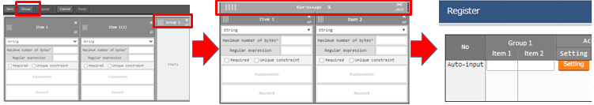

**Figure 5.1-2 column group creation**

* Repeat button

Click the “Repeat” button to set repeat items.

Repeat items and repeat count will automatically applied to vertical menu.

If you check the checkbox "Use" in the "Use vertical menu" column, the "Repeat" button will be enabled.

Users can set it by dragging and dropping items into the displayed REPEAT area.

(※)Vertical function is not applicable for data sheet.

Multiple items can be set in repeat column but only one repeat column can be set in a parameter sheet.

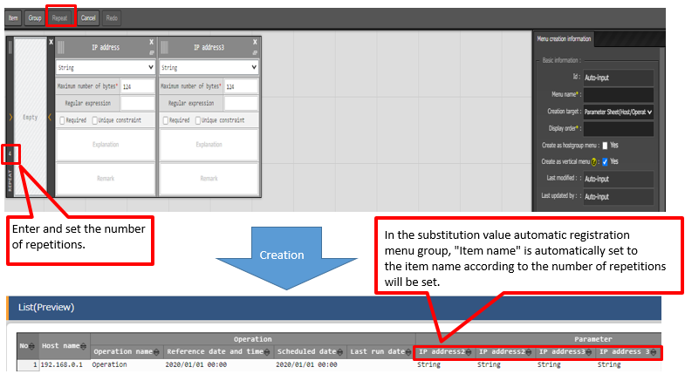

**Figure 5.1-3 create as vertical menu**

* Cancel button

Undo the previous modification.

* Redo button

Redo the cancelled modification.

## (B) Menu creation information tab

Enter required information for menu creation.

* Basic information

**Table 5.2-1 "Basic Information" Setting Value**

| **Item name** | **Description** | **Selected value of creation target** | |
| --- | --- | --- | --- |
| **Parameter**  **Sheet** | **Data Sheet** |
| Id | “Auto-input” is set on default when creating new menu.  The ID of menu will be displayed when editing existing menu. | Displayed | Displayed |
| Menu name | Enter the menu name of the menu to be created. The menu name “Main menu” cannot be used. | Displayed | Displayed |
| Creation target | Select 「Parameter Sheet (Host / Operation)」 or 「Data Sheet (master available)」 from the pull-down menu.  If "Data Sheet" is selected, the "Input" field will be displayed in the "Target Menu Group" frame.  If “Parameter sheet (With Operation" is selected, the "Create as Vertical Menu" checkbox will appear in the "Basic Information" frame.  Likewise, the "Input"," For Substitution value automatic registration" and "For reference" column" will be displayed in the "Target menu group" frame.  If “Parameter sheet (With Host/Operation" is selected, the "Create as Vertical Menu" checkbox will appear in the "Basic Information" frame.  Likewise, the "Input"," For Substitution value automatic registration" and "For reference" column" will be displayed in the "Target menu group" frame.  The default value is "Parameter sheet (with host/operation)" | Displayed | Displayed |
| Display order | Enter the display order in the menu group. They are displayed in ascending order. | Displayed | Displayed |
| Create as host group menu | When the "Use" check box is checked, "Host name/Host group name" parameter sheet in units is created in the "Input" menu group.  When the "Use" is checkbox not checked, "Host name" parameter sheet will be created.  ※When "Parameter sheet (with host/operation)" is selected in the "Target to create" column, the "Host group use" column will be displayed. |  | Hidden |
| Create as vertical menu | When "Parameter sheet" is selected in the "Creation target" column, the "Vertical menu use" column will be displayed.  When the "Use" checkbox is checked, a parameter sheet corresponding to the vertical menu will be created. |  | Hidden |
| Last modified | “Auto-input” is set on default when creating new menu.  The time of last modification will be displayed in view/edit mode. | Displayed | Displayed |
| Last updated by | “Auto-input” is set on default when creating new menu.  The name of the user who last modified the menu will be displayed in view/edit mode. | Displayed | Displayed |

* Target menu group

The menu groups that the menu to be created belongs to is displayed.

Click the “Target menu group” button to display the “Target menu group” modal to select the menu group for the menu to be created.

**Table 5.2-2 Target menu group frame setting value**

| **Item name** | **Description** | **Selected value of creation target** | |
| --- | --- | --- | --- |
| **Parameter**  **Sheet** | **Data Sheet** |
| For input | The initial value is the "For input" menu group.  The menu group name selected in the "For input" column on the "Menu Group Selection" screen will be displayed.  ※Selection required item. | Displayed | Displayed |
| For substitution value automatic registration | The initial value is the "substitution value automatic registration" menu group.  If the "Creation target" column is "Parameter sheet", the menu group name selected in the "For automatic registration substitution value" column on the "Menu group selection" screen will be displayed. ※If the "Target menu group selection" frame is displayed, it is a selection required item. | Displayed | Hidden |
| For reference | The initial value is the "For reference" menu group.  If the "Creation target" column is "Parameter sheet", the menu group name selected in the "For reference" column on the "Menu group selection" screen will be displayed.  ※If "Target menu group selection" frame is displayed, It is a selection required item. | Displayed | Hidden |

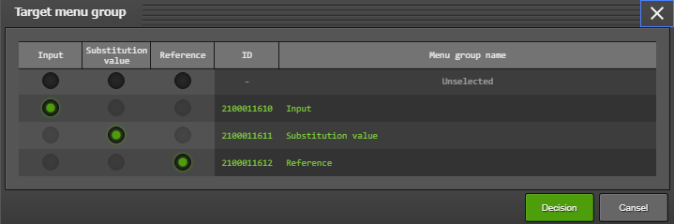

**Figure 5.2-1 Target menu group screen**

※This picture shows when "Parameter sheet" is selected in the "Creation target column.

* "Target menu group" screen
* Select the menu group where you want to create the menu (Parameter sheet/Data sheet)
* "For input", "For Substitution value automatic registration" and " For reference" menu groups are selected by default
* Select the menu group you want to use and press the "Decision" button.
* If you press the "Decision" button with the default settings~ will automatically be created. (When "Datasheet" is selected in the "Creation target" field, only the "For input" menu group will be created.)
* If the default menu group is not going to be used, please create the menus in the "Management console" menu group in advance. (For information about creation, please refer to the "ITA-User_Instruction_Manual_Management Console".)
* To return to the "Definition/list menu" menu, press the "Cancel" button.

・"Permission role" frame

* If permission role is selected
* Menu definition (each menu under the "Create menu" menu group) can only be accessed from selected roles.
* Created menus (parameter sheet/data sheet) can only be accessed by the selected roles set in the "Role/menu link list" menu.
* If no role is selected
* Menu definition (each menu under the "Create menu" menu group) is accessible by all roles.
* Created menus (parameter sheet/data sheet) can only be accessed by "System Administrator" roles and the role group of the user who created the menu.

## (C) Execute menu creation

* “Preview” Tab

The items to be created is displayed in table format.

* “Log” Tab

The result of menu creation after clicking the create button will be displayed.

* Create button (When creating new menu)

Menu (parameter sheet/data sheet) creation will be performed when clicking “Create” button after entering all required item.

The following dialog will be displayed after clicking “OK” button of confirmation dialog.

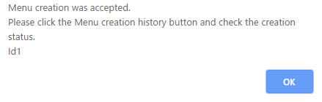

**Figure 5.3-1 Menu confirmation dialog**

Please move the “Menu creation history” menu to check if the menu is created normally after the creation is performed.

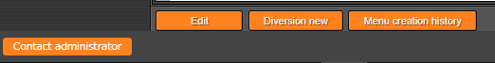

**Figure 5.3-2 View screen “Menu creation history” button**

When creating menus in “Define/Create menu (parameter sheet/data sheet)” screen, the information of the created menu will be automatically registered to “Menu definition information”, “Column group list”, “Menu item creation information”, “Vertical menu creation information”

## Usage of 「Define/Create Menu」after menu creation

Users can edit created menu or use created menu as template to create new menu (parameter sheet/data sheet) after creating menu in “Define/Create Menu”.

・“View mode screen”

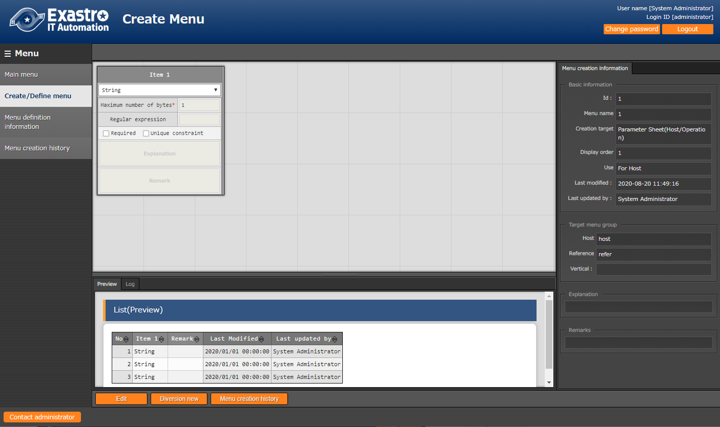

**Figure 5.4-1 View mode screen**

After creating new menu, the screen will move to above screen.

It is not possible to create or edit menus (Parameter sheets/data sheets) on the view screen.

Users can edit and create by pressing the "Edit", "Diversion new" and "Menu creation history" buttons displayed on the screen.

* Edit button

Pressing the "Edit" button will move the user from the View screen to the Edit screen.

Editing any value and pressing the "Create" button will re-create the menu (Parameter sheet/Data sheet) of the value.

* Diversion new button

"Clicking the "Diversion new" button will take the user to a screen where they can create a new menu template from the menu currently displayed on the screen.

Please enter new menu name and display order for the new menu.

Make sure the new name is different from any existing menu name.

* Menu creation history button

Moves the user to the "Menu creation history" menu of the menus being displayed in the view screen.

・“Edit mode screen”

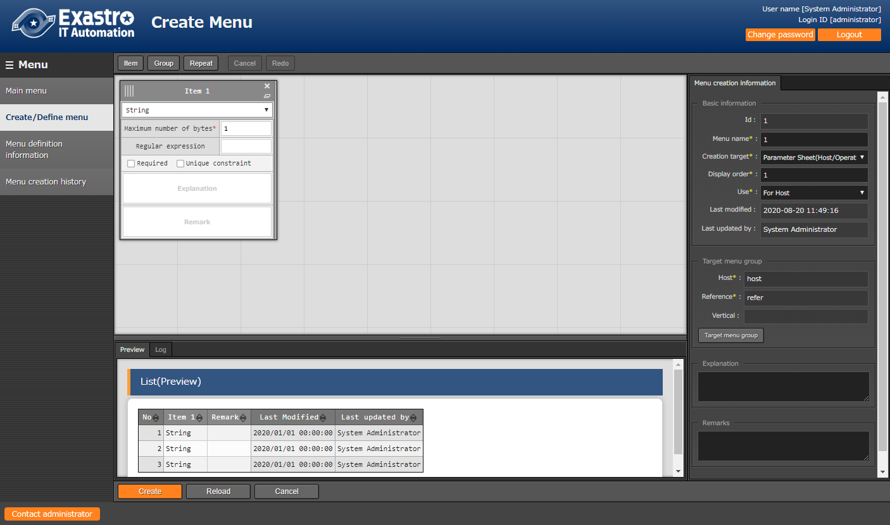

**Figure 5.4-2 Edit screen**

In the edit screen, users can edit menus displayed on the screen.

* Creation button

Menus (parameter sheet/data sheet) displayed on the edit screen will be re-created.

※When editing existing menu, since exchanging the name of items among the items is invalid, error may occur when changing the name of items.

* Reload button

Discard the edited content then return to the status of the original menu.

* Cancel button

Return to the status before clicking the edit button.

## Check created menu in「Menu definition information」

In the "Menu definition list" menu, users can check and operate the following.

* A list of created menus (parameter sheets/data sheets).
* Maintenance (view/update/abolition/restore) of created menus(parameter sheets/data sheets)
* Create menus (parameter sheet/datasheet) that do not use the "Define/create menu".

Menus (parameter sheet /data sheet) maintenance (view/update/abolition/restore) is possible.

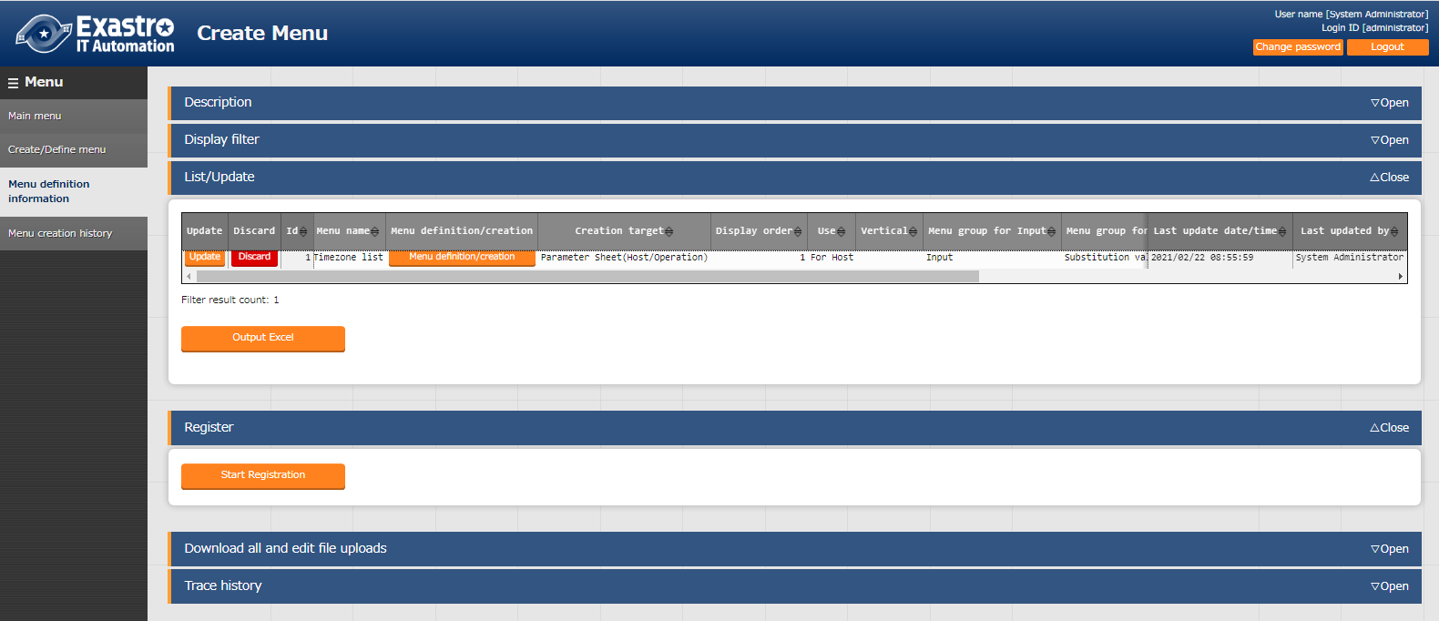

**Figure 5.5-1 Menu definition list menu**

Created menus (parameter sheet/data sheet) is displayed in “Menu definition list” > “List/Update”. Click “Filter” button in display filter to show all menus.

Click the “Menu definition/creation” button to move to “Create/Define menu” menu in view mode.

※The following are the steps to create menu in “Menu definition information” menu. These steps are not needed to create menu in “Create/Define menu” menu.

**Table 5.5-1 Menu definition list menu setting value**

| **Item name** | **Description** | **Selected value of creation target** | |
| --- | --- | --- | --- |
| **Parameter**  **Sheet** | **Data Sheet** |
| Menu name | Enter the menu name of the menu to be created. The menu name “Main menu” cannot be used. | Displayed | Displayed |
| Creation target | Selecting 「Parameter Sheet (Host / Operation)」 or 「Data Sheet (master available)」 from the pull-down menu, the color of the header will change in the "List/Update" Submenu and the "Registration" submenu.  If "Parameter sheet (with host/operation)" is selected , "Display order" column, "Use" column, "Vertical menu use" column, "Input menu group" column, "Menu group for substitution value automatic registration", "Menu group for reference", "Description" column, "Access permission" column, and "Remarks" column will be displayed as setting points.  If "Parameter sheet (with operation)" is selected, "Display order" column, "Vertical menu use" column, "Menu group for input", "Menu group for substitution value" automatic registration, "Menu group for reference", "Description" column, "Access permission" column, and "Remarks" column will be displayed as setting points.  If "Data Sheet" is selected, the "Display order" column, the "Input menu group" column, the "Description" column, the "Access permission" column, and the "Remarks" column will be displayed as setting points.  The initial value is "Parameter sheet (with host/operation)". | Displayed | Displayed |
| Display order | Enter the display order in the menu group. They are displayed in ascending order. | Displayed | Displayed |
| Use | If "Parameter sheet (with host/operation)" is selected in the "Creation target" column, the "Use" column will be displayed.  If "Host" is selected, a parameter sheet will be created in "Host name" unit.  When "For host groups" is selected, a parameter sheet is created in "Host name/Host group name" units in the "Input" menu group. | Displayed | Hidden |
| Create as vertical menu | If "Parameter Sheet" is selected in the "Creation target" column, the "Vertical menu use" column will be displayed.  if "●" is selected from the pull-down, a parameter sheet corresponding to the vertical menu will be created. | Hidden | Displayed |
| Menu group for input | If the "Creation target" field is "Parameter sheet" and "Data sheet", the "Menu group for input" column will be displayed.  Select the menu group where you want to create Parameter and Data sheets from the pull-down menu. | Displayed | Displayed |
| Menu group for substitute value automatic registration | If the "Create target" column is "Parameter sheet", the "Menu group for substitution value automatic registration" column will be displayed.  Select the Menu group for substitution value automatic registration where you want to create Parameter sheet from the pull-down menu. | Displayed | Hidden |
| Menu group for reference※ | If the "Creation target" column is "Parameter sheet", the "Menu group for reference" column will be displayed.  If the default menu group is not going to be used, please create the menus in the "Management console" menu group in advance. | Displayed | Hidden |
| Description | Enter the content to be displayed in the description column of the menu screen. | Displayed | Displayed |
| Remarks | Free description field | Displayed | Displayed |

(**※**) Please create the menu group using 「Management Console:Menu Group Management」 in advance. Please refer to 「User Instruction Manaual_Management Console」 for how to create a menu.

## Check the status of creation using「Menu creation history」

Check the status of menu creation list on the parameter sheet or data sheet.

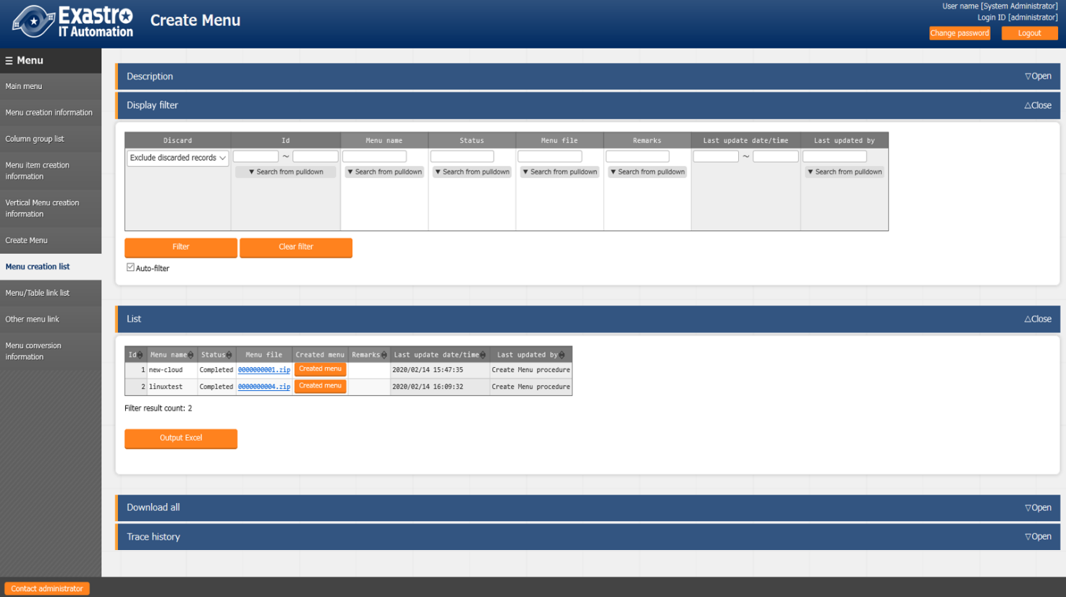

**Figure 5.6-1 "Menu creation history" menu**

BackYard monitors the status「unexecuted」, and creates a menu screen setting file based on the unexecuted data, which executes SQL Commands to create a table and registers the menu screen program.　After several tens of seconds, when the status changes to 「Completed」,　the menu will be created.

**Table 5.6-1 "Menu creation history" each menu item**

|  |  |
| --- | --- |
| **Item name** | **Description** |
| Menu name | Name of the menu to be created |
| Status | Menu creation status.  Unexecuted: status before menu creation  Executing: BackYard is executing the menu creation process  Completed: Menu creation completed successfully  Completed (error): When creating the menu ended with an error |
| Menu file | The PHP file and SQL file used in the menu.  If BackYard is seperated from the web server, this file is required to be placed on the web server. Refer to 「8.1 Placing PHP files」 |
| Created menu | If the status is "Completed", pressing the "Created Menu" button will open the created menu (parameter sheet/data sheet) screen in a different tab.  Moves the user to the menu (parameter sheet/data sheet) of the menu group set in the menu group for input. |
| Remarks | Free description field |

## Check the created menu

"Menu Creation" menu group > "Menu definition/creation" menu> "Menu creation information" tab> "Basic information" frame.

This section explains the menus (parameter sheets/data sheets) in pattern 1~5 below. They are created according to the values selected in the "Basic Information" frame.

1. **Data sheet**

* Menu group for input

1. **Parameter sheet (with operation)**

* Menu group for input
* Menu group for substitution value automatic registration
* Menu group for reference

1. **Parameter sheet (with host/operation)**

* Menu group for input
* Menu group for substitution value automatic registration
* Menu group for reference

1. **Parameter sheet (with host/operation) & Create as host group menu**

* Menu group for input
* Menu group for substitution value automatic registration
* Menu group for reference

1. **Parameter sheet & Create as vertical menu**

* Menu group for input
* Menu group for substitution value automatic registration
* Menu group for reference

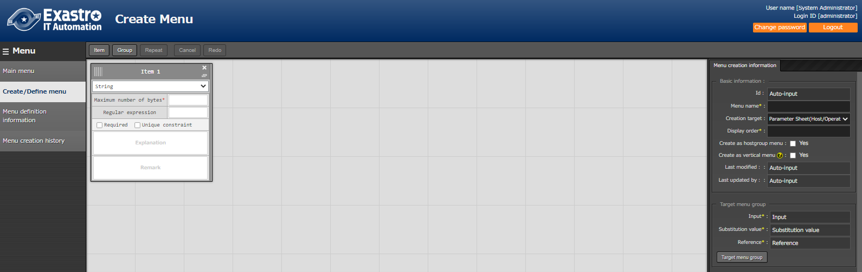

**Figure 5.7-1 Selection of "Basic Information" frame**

1. If "Data sheet" is selected in the "Creation target" column

If "Data sheet" is selected in the "Creation target" column of the "Menu definition/create menu" (or Menu definition list" menu) when the user is creating a menu, a data sheet will also be created.

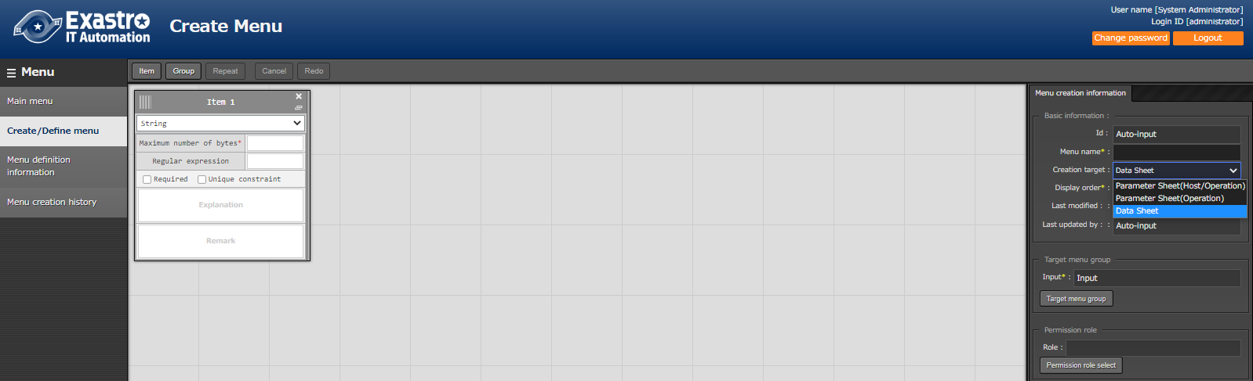

**Figure 5.7-2 Data sheet creation**

Check that a datasheet has been added to the menu group specified in the "Input (menu group)" field.

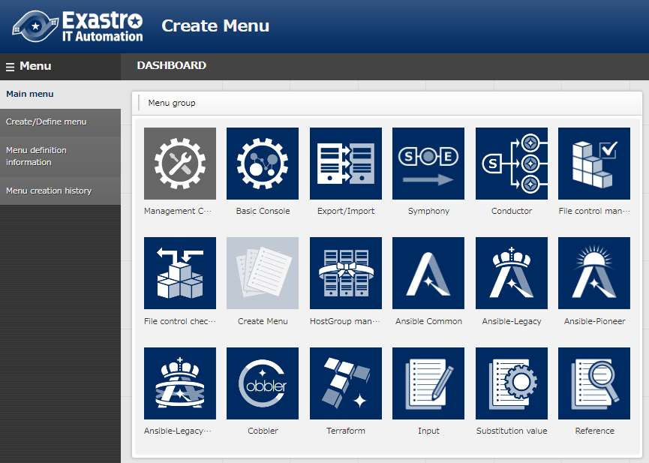

**Figure 5.7-3 Menu group for input**

1. **Menu group for input**

A data sheet that can be maintained (register/update/abolition/restore) will be created.

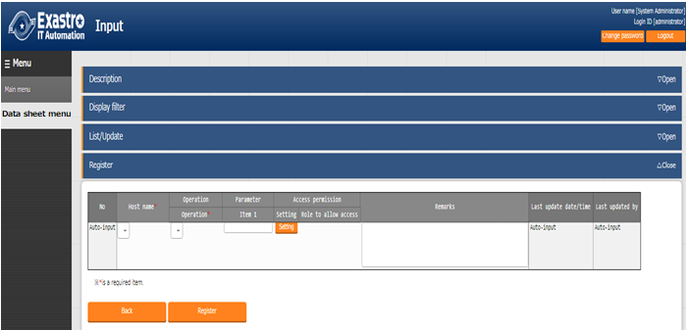

**Figure 5.7-4 Data sheet created under menu group for input**

※The datasheet is not linked to a specific host/operation, so host/operation items will not be displayed.

※Data sheets will not be created for the "For substitution value automatic registration" and "For reference" menu groups.

1. If "Parameter sheet(with operation)" is selected in the "Creation target" column

When creating a menu (parameter sheet/ datasheet), if "Parameter sheet (with operation)" is selected in the "Creation target" column of the "Menu definition/create" menu (or "Menu definition list" menu), a parameter sheet for each operation will be created.

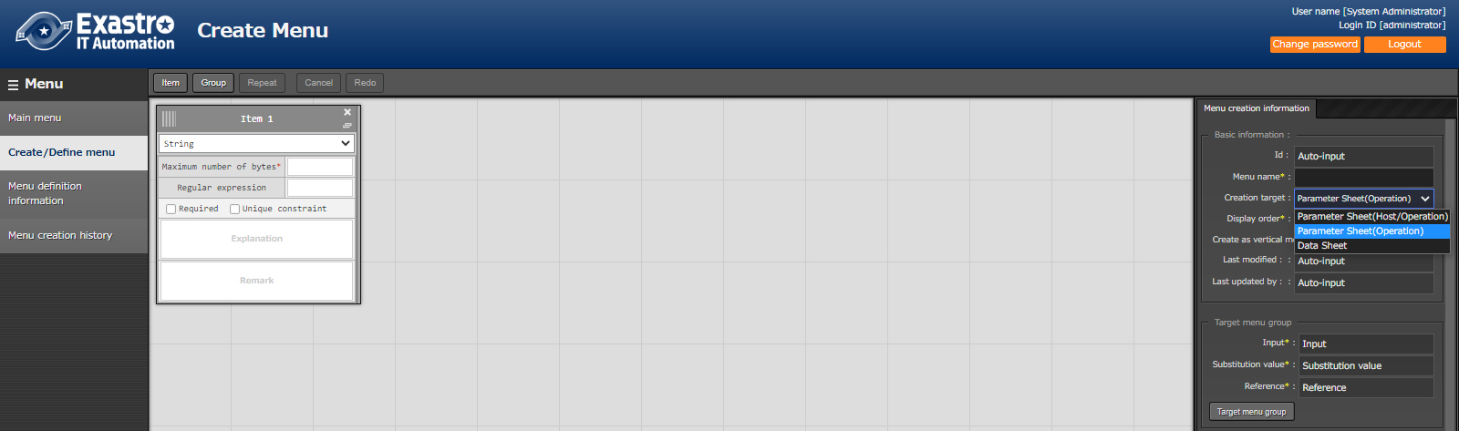

**Figure 5.5-7 Parameter sheet (with operation) creation**

Check that a parameter sheet has been added to the menu group specified in the "Input (menu group)" column, "Substitution value auto list (menu group)" column and "Reference (menu group)" column.

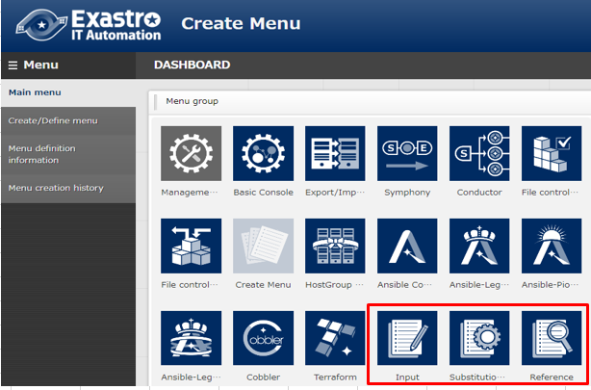

**Figure 5.7-6 Menu group for "Input", "Substitution value automatic registration",” Reference"**

1. **Menu group for input**

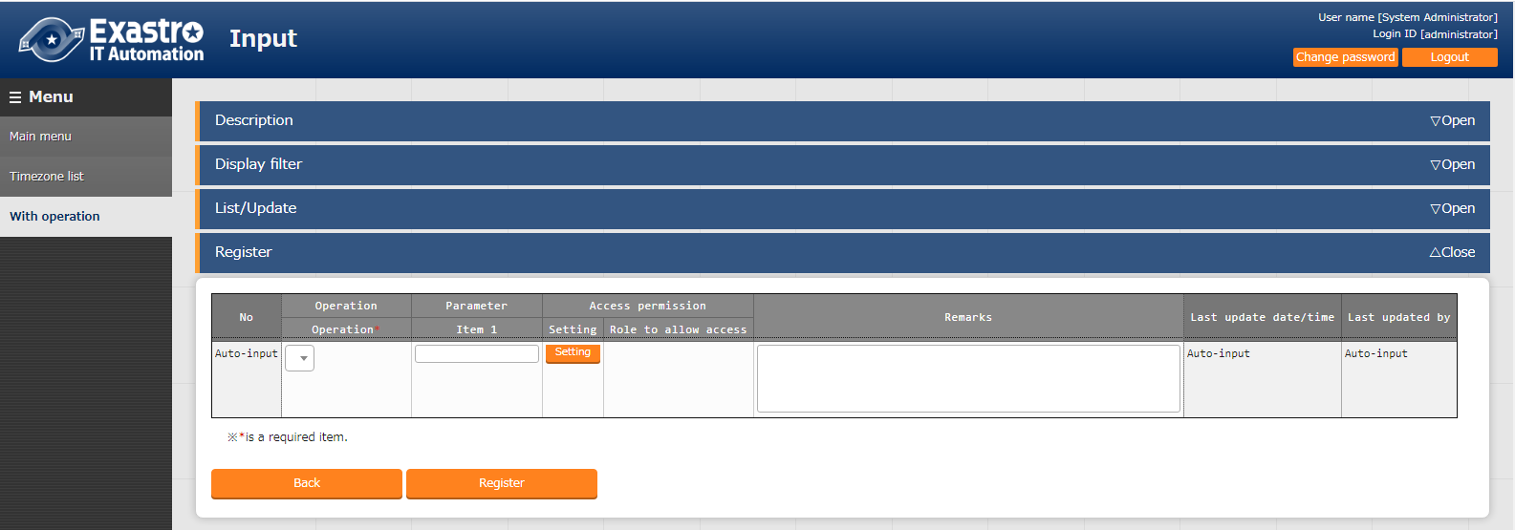A parameter sheet that can be maintained (register/update/abolition/restore) will be created.

**Figure 5.7-7 Parameter sheet created under menu group for input**

1. **Menu group for substitution value automatic registration**

This is a menu for viewing only. The contents registered in the menu group for input will be displayed in the "list" submenu in operation units.

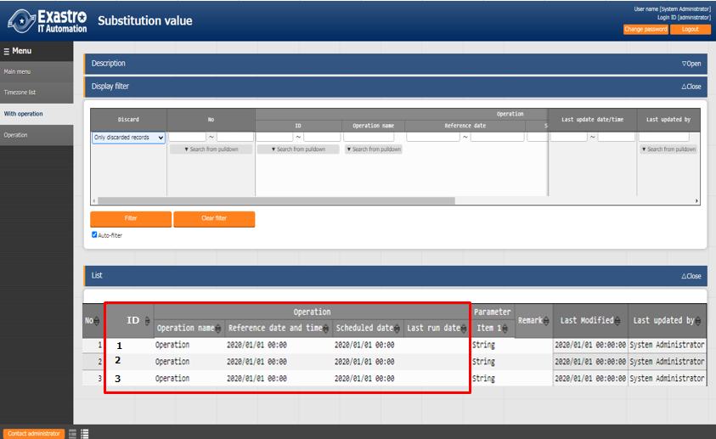

**Figure 5.7-8 Parameter sheet created under menu group for substitution value automatic registration**

1. **Menu group for reference**

This is a menu for viewing only. The settings enabled at the time of the specified date and time in the "Operation: Reference date and time" column of the "Display Filter" sub menu will be displayed in the "List" sub menu.

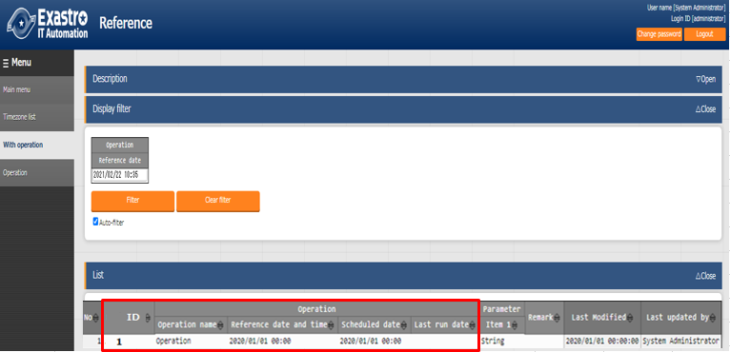

**Figure 5.7-9 Parameter sheet created under menu group for reference**.

※If the filter button is clicked when the "Operation: Reference date" field in the "Display filter" submenu is blank, only the latest data in the "Reference Date" field for each operation will be displayed in the "list" submenu.

1. If "Parameter sheet(with host/operation)" is selected in the "Creation target" column

When creating a menu (parameter sheet/datasheet), if "Parameter sheet (with host/operation)" is selected in the "Creation target" column of the "Menu definition/create" menu (or "Menu definition list" menu), a parameter sheet will be created per host name.

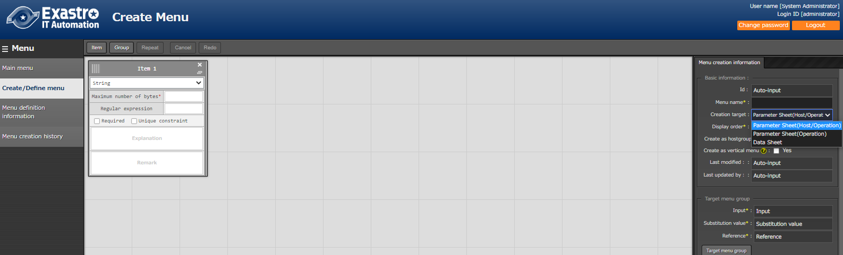

**Figure 5.7-10 Parameter sheet (with host/operation) creation**

Check that a parameter sheet has been added to the menu group specified in the "Input (menu group)" column, "Substitution value automatic list (menu group)" column, and "Reference (menu group)" column.

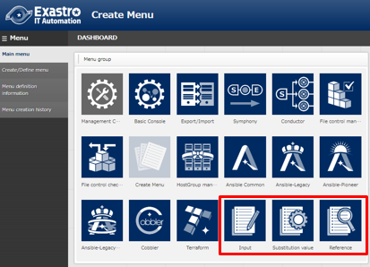

**Figure 5.7-11 Menu group for "Input", "Substitution value automatic registration",” Reference"**

1. **Host group for input**

A parameter sheet that can be maintained (register/update/abolition/restore) will be created.

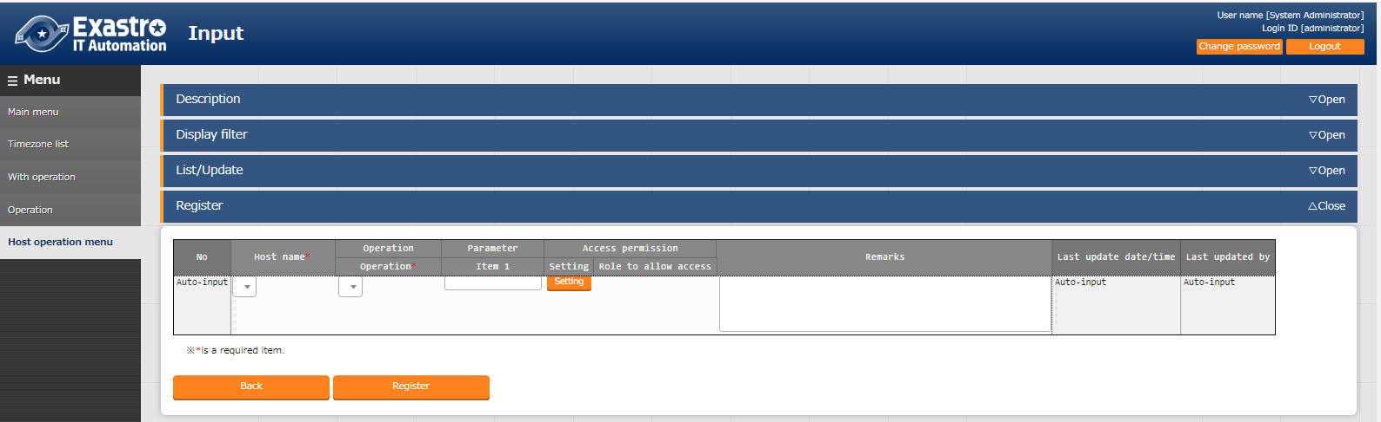

**Figure 5.7-12 Parameter sheet created under menu group for input.**

1. **Menu group for substitution value automatic registration**

This is a menu for viewing only. The contents registered in the menu group for input will be displayed in the "list" submenu in operation units.

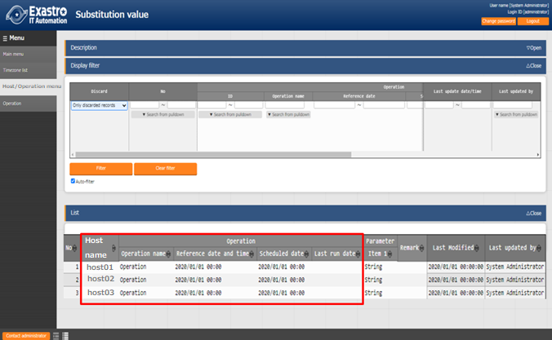

**Figure 5.7-13 Parameter sheet created under menu group for substitution value automatic registration**

1. **Menu group for reference**

This is a menu for viewing only. The settings enabled at the time of the specified date and time in the "Operation: Reference date and time" column of the "Display Filter" sub menu will be displayed in the "List" sub menu.

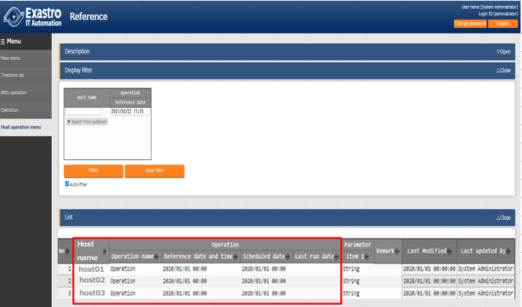

**Figure 5.7-14 Parameter sheet created under menu group for reference**

※If the filter button is clicked when the "Operation: Reference date" field in the "Display filter" submenu is blank, only the latest data in the "Reference Date" field for each operation will be displayed in the "list" submenu.

1. Select "Parameter sheet (with host/operation)" in the "Create target" column

If "Create as host group menu" is checked in the checkbox.

When creating a menu (parameter sheet/datasheet), "Parameter sheet (with host/operation)" in the "Creation target" column of the "Menu definition/create" menu (or "Definition menu list" menu).

If the "Use" checkbox in the "Create as host group menu" column is checked, a parameter sheet will be created for each host name/host group name.

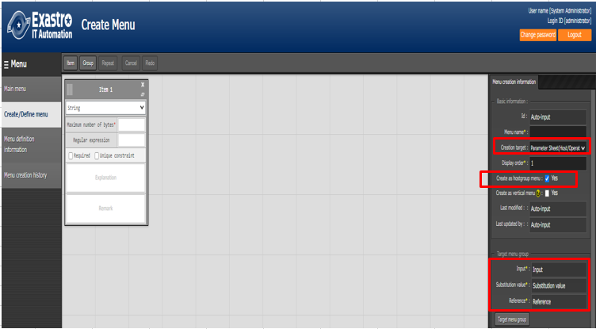

**Figure 5.7-15 parameter sheet (create as host group menu) creation**

Check that a parameter sheet has been added to the menu group specified in the "Input (menu group)" column, "Substitution value automatic list (menu group)" column, and "Reference (menu group)" column.



**Figure 5.7-16 Menu group for "Input", "Substitution value automatic registration", and "reference" Menu group**

1. **Menu group for input**

A parameter sheet that can be maintained (register/update/abolition/restore) will be created.

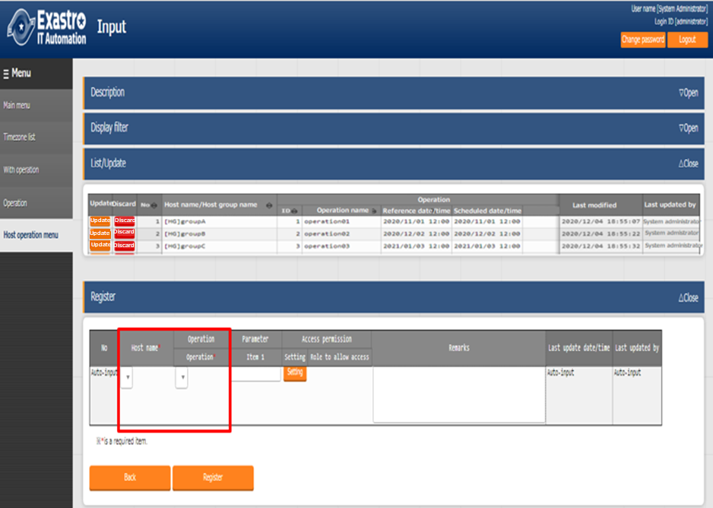

**Figure 5.7-17 Parameter sheet created under menu group for input**

In the "Host name/host group name" column of the "Registration" sub menu, the host group name will be displayed as [HG] at the beginning of the name. The host name will be displayed as [H] at the first of the name.

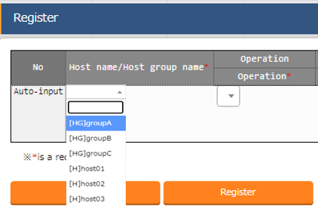

**Figure 5.7-18 "Host name/host group name" column**

1. **Menu group for substitution value automatic registration**

This is a menu for viewing only. The contents registered in the menu group for input will be displayed in the "list" submenu in operation units.



**Figure 5.7-19 Parameter sheet created under menu group for substitution value automatic registration**.

1. **Menu group for reference**

This is a menu for viewing only. The settings enabled at the time of the specified date and time in the "Operation: Reference date and time" column of the "Display Filter" sub menu will be displayed in the "List" sub menu.



**Figure 5.7-20 Parameter sheet created under menu group for reference**

※If the filter button is clicked when the "Operation: Reference date" field in the "Display filter" submenu is blank, only the latest data in the "Reference Date" field for each operation will be displayed in the "list" submenu.

1. Select "Parameter sheet" in the "Creation target" column

If "Create as vertical menu" is checked in the checkbox.

When (parameter sheet/datasheet) menu is creating, select "Parameter sheet (with operation)" and "Parameter sheet (with host/operation)" in the "Creation target" column of the "Menu definition/create" menu (or "Menu definition list" menu). If "Use" of "Create as vertical menu "column is checked in the checkbox, a vertical parameter sheet is created where the created item is according to the number of REPEAT.

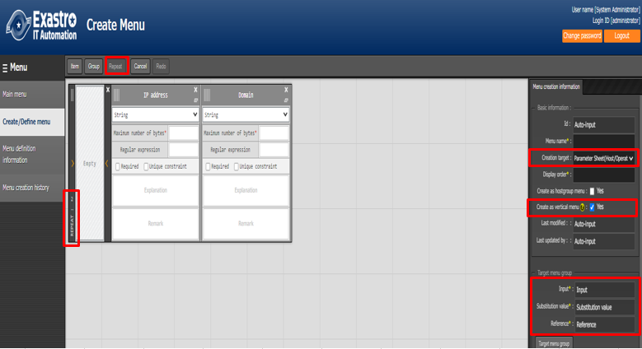

**Figure 5.7-21 parameter sheet (Create as vertical menu) creation**

Ex) Parameter list included in hosts file

As shown in the hosts file below, it is possible to use the parameter sheet to register the "IP Address and "Domain" four times repeatedly.

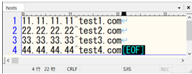

**Figure 5.7-22 hosts file**

Check that a parameter sheet has been added to the menu group specified in the "Input (menu group)" column, "Substitution value automatic list (menu group)" column, and "Reference (menu group)" column.



**Figure 5.7-23 Menu group for "Input", "Substitution value automatic registration”, "Reference"**

* 1. **Menu group for input**

A parameter sheet will be created that can be maintained (register/update/abolition/restore) on host name unit. (If the host group user checkbox is checked, maintenance can be performed for each host group name unit.)

For registered "host name" and "operation" combinations, it is possible to set multiple parameters by entering the "Substitution order" column.

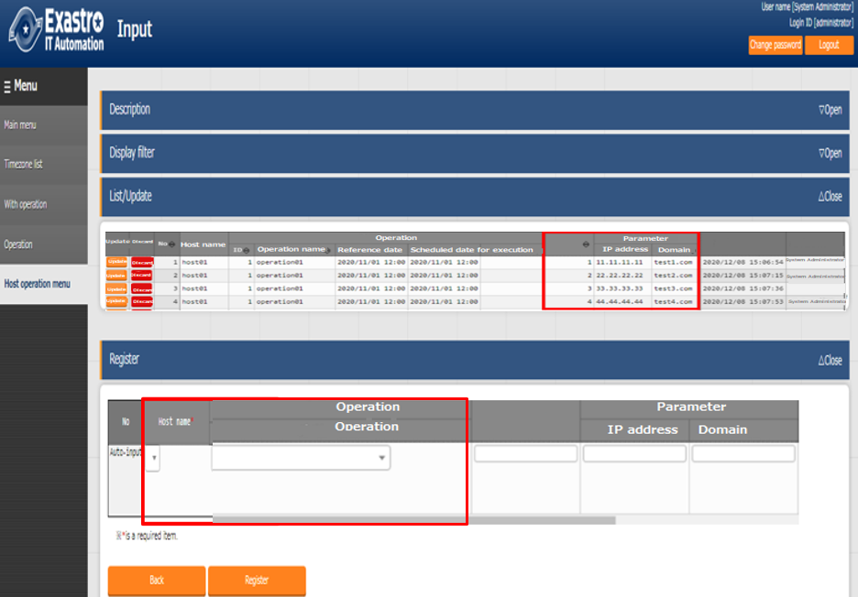

**Figure 5.7-24 Parameter sheet created under menu group for input.**

※In the case of the "4 : REPEAT" setting, it is possible to register substitution orders later than 4. However, when the menu is expanded horizontally, substitution order 4 and later ("55.55.55.55" and "test5.com") are ignored.

Ex) If the user attempt the registration above without using the vertical menu (1)

Users cannot set more than one parameter for a registered host name and operation combination.

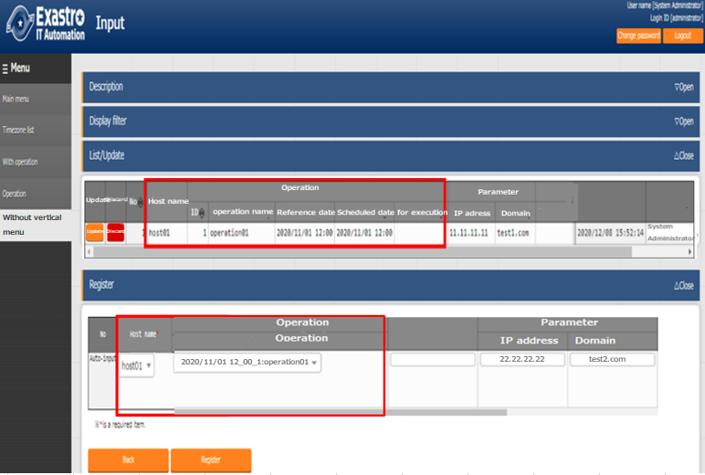

**Figure 5.7-25 Parameter sheet created under menu group for input**

※When "11.11.11.11" and "test1.com" are already set for the combination "host01" and "operation01", if you try to set "22.22.22.22" and "test2.com" in the same way, an error will occur.

Ex) If the user attempt the registration above without using the vertical menu (2)

If the user wants to set multiple parameters for a registered combination of "host name " and "Operation", it can be done by increasing the number of items. However, the parameter sheet will be displayed horizontally and the visibility will be poor.

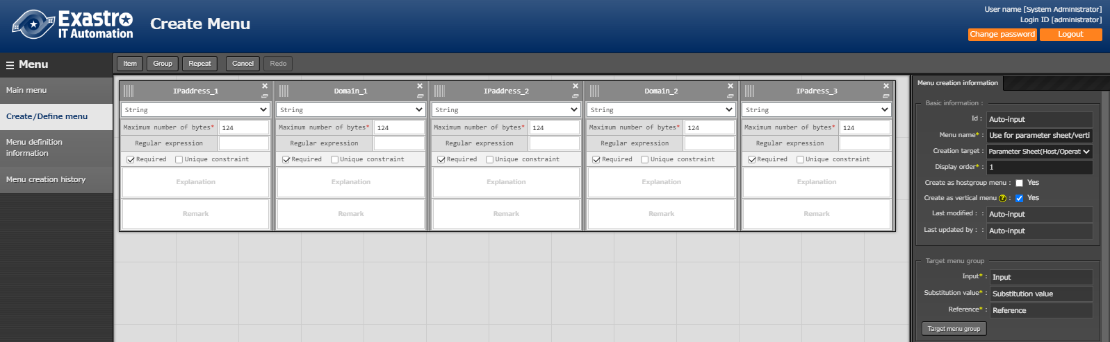

**Figure 5.7-26 “Menu defination/creation” menu**

※It is possible to set parameters > created items in the "Menu definition/creation" menu in the "Create menu" menu group.

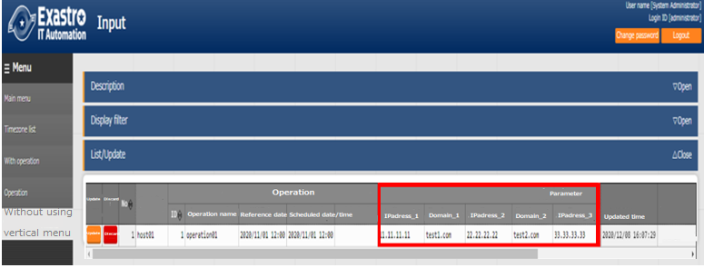

**Figure 5.7-27 Parameter sheet created under menu group for input.**

※For the case above, Items up to "IP Adress_4" and " Domain_4" are created. Items after that are not created.

Also, because there are no items, users cannot register content ("55.55.55.55", "test5.com") that corresponds to "IP address_5" or "domain_5" for the same combination of "host name" and "operation".

If you want to create a parameter sheet that repeats the same item, as in the hosts file, we recommend that you use the vertical menu. (Vertical menus cannot be used for data sheets.)

1. **Menu group for substitution value automatic registration**

This is a menu for viewing only. The contents registered in the input menu group are displayed in the "List" sub menu in a format that is automatically converted from the vertical menu to the normal menu (horizontal display).

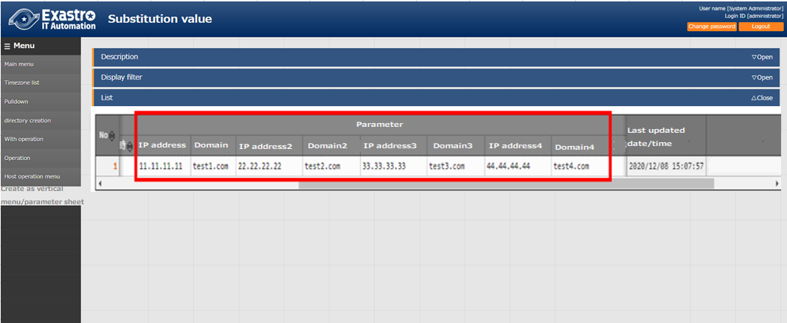

**Figure 5.7-28 Parameter sheet created under menu group for substitution value automatic registration.**

For each combination of "host name " and "operation", the registration contents will be displayed in one line.

"Item name [Repeat number]" will be displayed in the parameters.

1. **Menu group for reference**

This is a menu for viewing only. The settings enabled at the time of the specified date and time in the "Operation: Base date and time" column of the "Display Filter" sub menu will be displayed in the "List" sub menu in combination of "Host Name" and "Operation".



**Figure 5.7-29 Parameter sheet created under menu group for reference**

※If the filter button is clicked when the "Operation: Reference date" field in the "Display filter" submenu is blank, only the latest data in the "Reference Date" field for each operation will be displayed in the "list" submenu.

# Hidden menus of 「Create Menu」menu group

## Register a column group using 「Column group list」

During installation, the Column group list menu will not be displayed.

The column groups of sheets that belong to the menu to be created can be maintained (View/Update/Discard/restore).

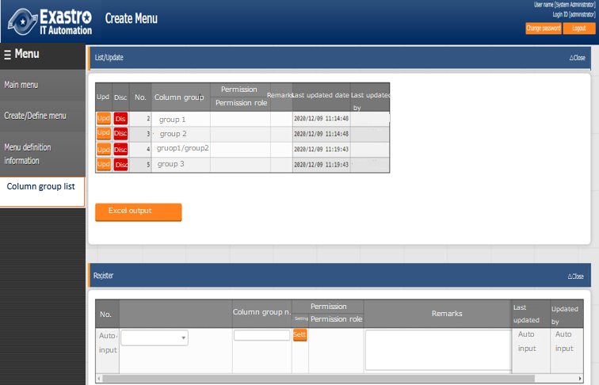

**Figure 6.1-1 “Column group list” menu**

A column group is a group that displays the heading portion of a menu item. The menu creation function allows users to create a column groups of items that they want to create. The red marked frame in the following example is the column group that can be created by the menu creation function

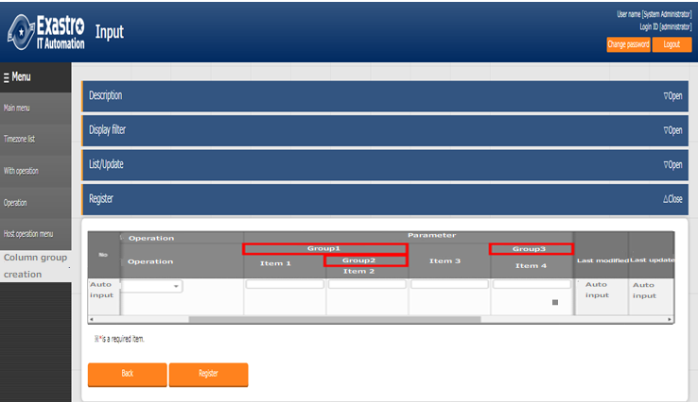

**Figure 6.1-2 Parameter sheet created under menu group for input**

**Table 6.1-1 "Column group list" menu configuration value**

|  |  |
| --- | --- |
| **Item name** | **Description** |
| Column group | The name of the parent column group and the column group will be displayed as a 「/」 connection.  ※Displayed in the "List/Update" sub-menu.  ※With "Update" and "abolition/restore" button. |
| New column group | Select the parent column group from the pull-down.  ※Displayed in the "Update" button and "Register" sub menu of the "List /Update" sub menu |
| Column group name | Enter the column group name  ※Displayed in the "Update" button and "Register" sub menu of the "List /Update" sub menu |
| Remarks | Free description field |

The following checks are performed at the time of updating/discard.

1. The data itself cannot be selected as a parent column group.
2. If it is specified in the parent group of other data, it cannot be discarded.
3. A parent-child relationship that results in a loop relationship cannot be set. (If the parent-child relationship is A⇒B⇒C, C cannot be specified as the parent of A.).

## Register items to be set using「Menu item creation information」

During installation, the Column group list menu will not be displayed.

The items managed in the parameter sheet or data sheet menu to be created can be maintained (View/Update/Discard/restore).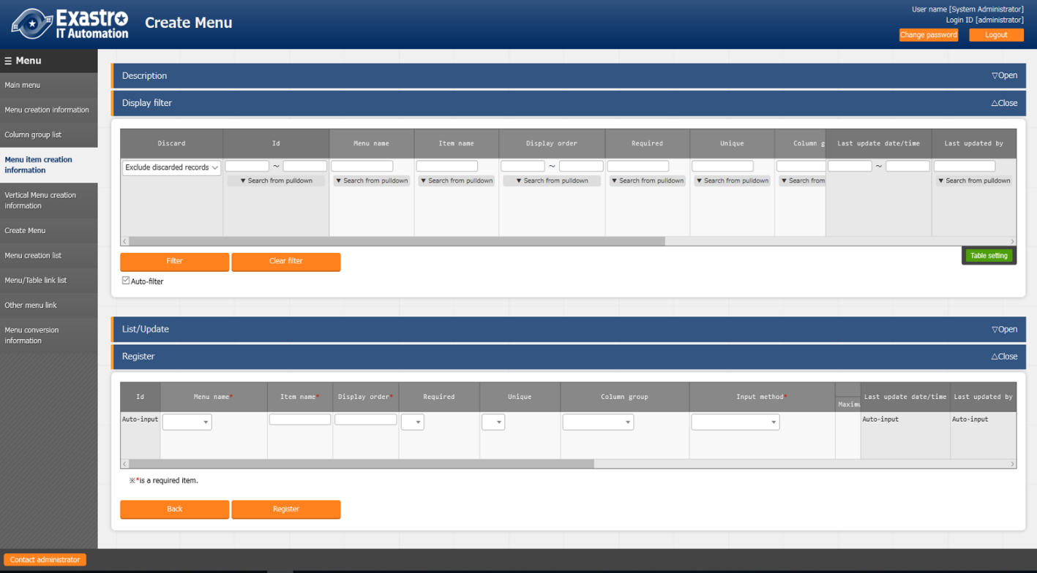

**Figure 6.2-1 "Menu item creation information" menu**

**Table 6.2-1 "Menu item creation information" menu configuration value**

| **Settings** | | **Description** |
| --- | --- | --- |
| Menu name | | Select the menu (parameter sheet/ data sheet) to link items from the pull-down. |
| Item name | | Enter the item name to be displayed on the menu  .※ Do not use 「/」 in the item names. When 「/」 is used, the  「Substitute value auto registration setting」 in each driver may not work properly. |
| Display order | | Enter the order of the columns displayed in the menu. They are displayed in ascending order from the left. |
| Required | | To make it a required item, select 「●」 from the pull-down menu. |
| Unique | | To make it a unique item, select 「●」 from the pull-down menu. |
| Column group | | Select the column group to which it belong from the pull-down menu. |
| Input method | | Selecte “String”, “Multi string”, “Integer”, “Decimal number”, “Date”, “Date/time”, “Pull down selection” from the pulldown menu.  When “String” is selected, the item is a text box with single line input.  When “Multi string” is selected, the item is a text box with multiple line input.  When “Integer” is selected, the item is a text box that only integer can be entered.  When “Decimal number” is selected, the item is a text box that integer/decimal number can be entered.  When “Date” and “Date/time” is selected, the item is entered by calendar selection.  When “Pulldown selection” is selected, the item is a pulldown menu item.  If "Password" is selected, the item will be a text box where any text typed in the box will be hidden with "●” ( The text will only be displayed if the eye icon inside the frame is pressed).  When "File upload" is selected, the item will contain 2 buttons. One where users can browse and select files, and one called "Pre-upload".  When "Link" is selected, the entered URL will be a text box item that will be displayed as a link.  ※ About the trace history of the menu created with 「Pulldown selection」 is selected, the supplement is described in 「8.5 Trace history when「Pulldown selection」is included in the sheet」.  ※The association target item in “Substitution value automatic registration setting” are “String”, “Multi string”, “Integer”, and “Decimal number”. “Date/time”, and “Date” can’t be associated. “Pulldown selection” can’t be associated if the item of pulldown selection are “Multi string”, “Date/time”, and “Date”. |
| String | Maximum number of bytes | Enter the maximum number of bytes.  The maximum size is 8192 bytes.  The byte count of half-width alphanumeric characters are equivalent to the number of characters.  For full-width characters, the number of characters x 3 + 2 bytes is required.  Required if “Input Method” is “String”.  Can’t be entered if “Input method” is “Multi string”, “Integer”, “Decimal number”, “Date/time”, “Date”, and “Pulldown selection”. |
| Regular expression | If you want to check input values with regular expression, enter the regular expression.  Example: For half-width numeric items of 0 bytes or more: /^[0-9]*$/  For half-width alphanumeric characters of 1 byte or more:/^[a-zA-Z0-9]+$/  Can’t be entered if “Input method” is “Multi string”, “Integer”, “Decimal number”, “Date/time”, “Date”, and “Pulldown selection”. |
| Multi string | Maximum number of bytes | Enter the maximum number of bytes.  The maximum size is 8192 bytes.  The byte count of half-width alphanumeric characters are equivalent to the number of characters.  For full-width characters, the number of characters x 3 + 2 bytes is required.  Required if “Input Method” is “Multi String”.  Can’t be entered if “Input method” is “String”, “Integer”, “Decimal number”, “Date/time”, “Date”, and “Pulldown selection”. |
| Regular expression | If you want to check input values with regular expression, enter the regular expression.  Example: For half-width numeric items of 0 bytes or more: /^[0-9]*$/  For half-width alphanumeric characters of 1 byte or more:/^[a-zA-Z0-9]+$/  Can’t be entered if “Input method” is “String”, “Integer”, “Decimal number”, “Date/time”, “Date”, and “Pulldown selection”. |
| Integer | Minimum value | Enter the minimum value of the column. Integer value from -2147483648 to 2147483647 can be entered.  The value will be -2147483648 if not entered.  Please enter value smaller than the maximum value.  Can’t be entered if “Input method” is “String”, “Multi string”, “Decimal number”, “Date/time”, “Date”, and “Pulldown selection”. |
| Maximum value | Enter the maximum value of the column. Integer value from -2147483648 to 2147483647 can be entered.  The value will be 2147483647 if not entered.  Please enter value larger than the minimum value.  Can’t be entered if “Input method” is “String”, “Multi string”, “Decimal number”, “Date/time”, “Date”, and “Pulldown selection”. |
| Decimal number | Minimum value | Enter the minimum value of the column. Integer value from -99999999999999 to 99999999999999 with total digit for whole number + fraction part less than 14 digits can be entered.  The value will be -99999999999999 if not entered.  Please enter value smaller than the maximum value.  Can’t be entered if “Input method” is “String”, “Multi string”, “Integer”, “Date/time”, “Date”, and “Pulldown selection”. |
| Maximum value | Enter the maximum value of the column. Integer value from -99999999999999 to 99999999999999 with total digit for whole number + fraction part less than 14 digits can be entered.  The value will be 99999999999999 if not entered.  Please enter value larger than the minimum value.  Can’t be entered if “Input method” is “String”, “Multi string”, “Integer”, “Date/time”, “Date”, and “Pulldown selection”. |
| Digits | Enter the upper limit of the total digit for whole number + fraction part.  Example: 0.123 has 4 digits (whole number 1 digit, fraction part 3 digits)  11.1111 has 6 digits (whole number 2 digit2, fraction part 3 digits)  Integer value from 1 to 14 can be entered.  Can’t be entered if “Input method” is “String”, “Multi string”, “Integer”, “Date/time”, “Date”, and “Pulldown selection”. |
| Pulldown selection | Menu group: Menu: Item | Select the target to refer to from the created menu (parameter sheet/data sheet) from the pull-down menu.  If the "Input method" is "Pull-down selection", selection is required.  ※Items that satisfy the following conditions are displayed in the pull-down menu.   * "Host name" and "IP address" item of "Basic console" menu group "Device list" menu. * If Ansible driver is installed, "Ansible Common" Menu group's, File list" menu's " File embedded variable name" item and "Template list" menu's "Template embedded variable name" item. * Items in which the input method of the menu (parameter sheet /data sheet) created by the function of the "Menu Creation" menu group is "string (single line)" , "string (multiple line)" , "integer" , "multiple line" , "integer," "number" , "date and time" , "date" , "link" or "required" and "unique constraint." |
| Password | Maximum numbers of bytes | Enter the maximum number of bytes.  The maximum is 8192 bytes.  For half size alphanumeric characters, it is the number of characters.  For full size characters, you will need (The number of characters) x 3 + 2bytes.  If the "input method" is "password", it is required to enter it. |
| File upload | Maximum numbers of file | Enter the maximum number of bytes of the file to upload.  The maximum is 4294967296 bytes.  If the "Input method" is "File upload", it becomes an required item. |
| Link | Maximum numbers of bytes | Enter the maximum number of bytes.  The maximum is 8192 bytes.  For half size alphanumeric characters, it is the number of characters.  For full size characters, you will need (The number of characters) x 3 + 2bytes.  If the "input method" is "password", it is required to enter it. |
| Description | | Enter the description that will be displayed when users hover mouse cursor over the item name. |
| Remarks | | Free description field |

## Vertical registration using「Vertical menu creation information」

Users can select the menu and start item name of the parameter sheet to be created, and specify the number of items and the number of repetitions for vertical management display.

(※) Vertical menus cannot be used for data sheets.

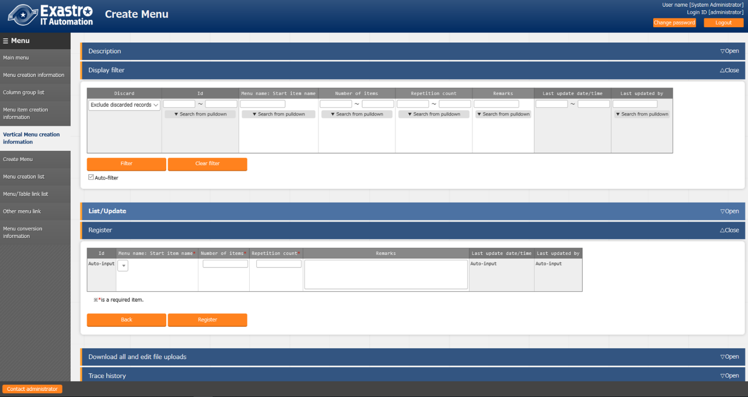

**Figure 6.3-1 "Menu (vertical) creation Information" menu**

**Table 6.3-1 "Menu (vertical) creation Information" menu setting value**

|  |  |
| --- | --- |
| Item name | Description |
| Menu name: Start item name | Select menu and start item name of the parameter sheet from pull-down menu. |
| Number of items | Enter the number of items from the start item. |
| Repetition count | Enter the number of repetition count in the vertical display. |
| Remarks | Free description field |

Example) Manage the parameters described in the hosts file.

hosts File



**Figure 6.3-2 hosts file**

When specifying IP address + domain name in set as described above , use 「Vertical menu (vertical) creation information」 and by setting the menu name: start item name to 「role: IP address」 and specify the number of items as 「2」 and repetition count as「4」, vertical display conversion is performed as below becoming more readable and management becomes easier.

Vertical menu creation information



**Table 6.3-3 "Menu (vertical) creation Information" menu**

In the example, the start item name specifies the leftmost 「IP address」 in the red frame below

Horizontal display



**Figure 6.3-4 Parameter sheet created under menu group for substitution value automatic registration**

Counting from the specified 「IP address」, the items until the second item 「domain name」 is displayed

Vertical display

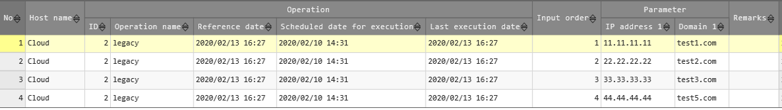

The parameter for the 2 items is displayed vertically for 4 times repeatedly.

**Figure 6.3-5 Parameter sheet created under menu group for reference**

## Create parameter sheet/data sheet using「Create menu」

During installation, the Column group list menu will not be displayed.

Create a menu (parameter sheet/datasheet) in the menu group specified in the "Menu Definition List" menu.

If a role is selected, the menu definition will only be accessible by the selected role. Created menus (Parameter sheets/ data sheets) can only be accessed by the selected role according to the settings in the "role/menu link list" menu.

If no role is selected, the menu definition will be accessible to all roles, and the created menu (Parameter sheets/ data sheets) will be accessible to only to the System administrator role and the role group of the user who created the menu (According to the role/menu link list" menu.

The menu (parameter sheet/ data sheet) that has been set for each item will be displayed in the "Create menu" sub menu. Check the menu you want to create and press the "Start menu creation" button.

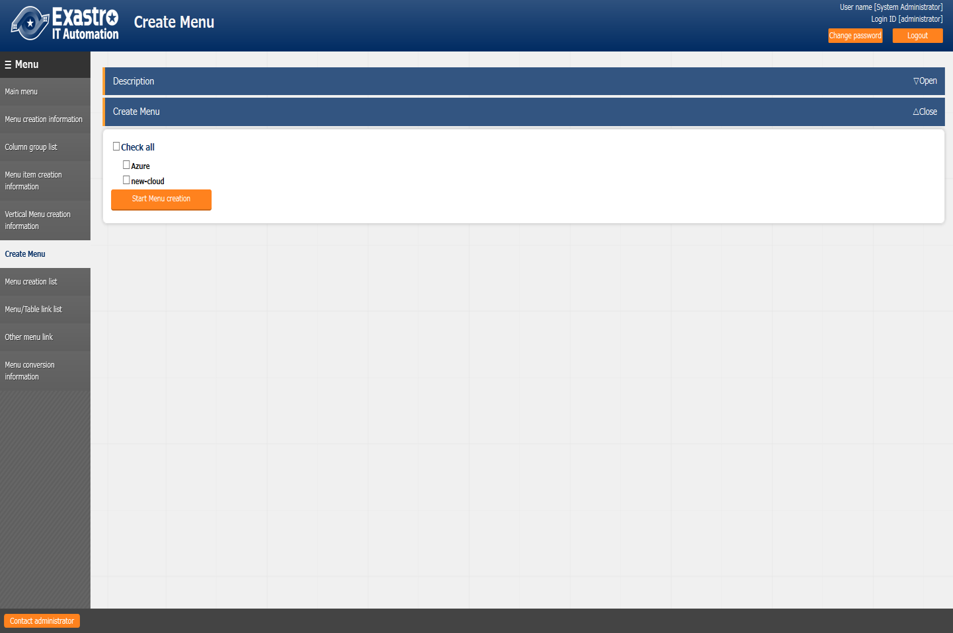

**Figure 6.4-1 "Menu creation execution" menu**

If a menu (parameter sheet/data sheet) with the same name has already been registered, or if a menu with the same item number in the "Menu Definition List" menu exists, the menu will be overwritten and the entered data will be deleted.

If you need the registered data, please select 「Cancel」 and back up the data

If the 「OK」 button in the confirmation dialog is clicked, the create request will be accepted.

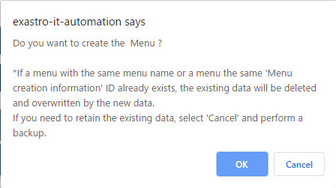

**Figure 6.4-2 Menu creation check dialog**

When you click the 「Menu Creation list」 button, the screen changes to 「Menu Creation list」 menu , which is displayed in a state filtered by 「ID」.

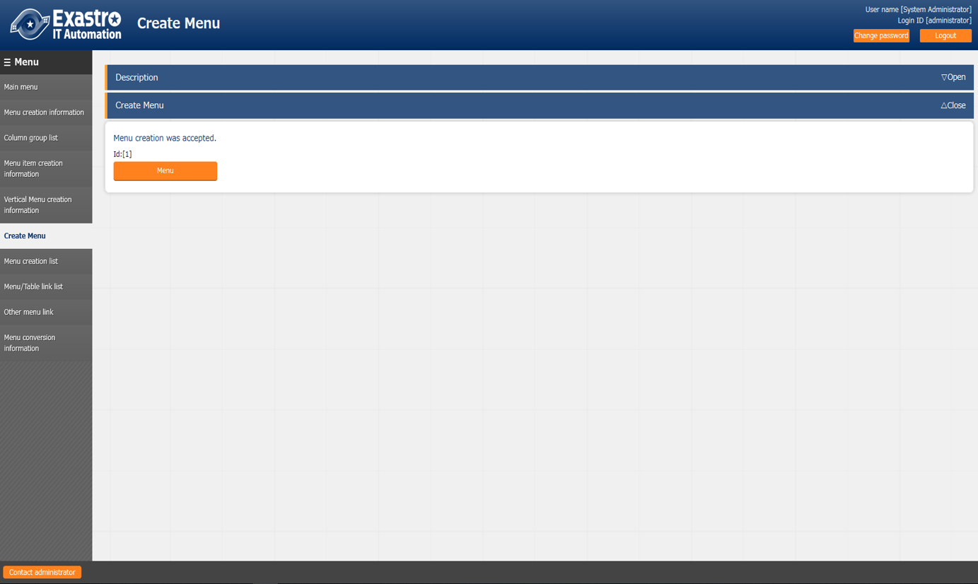

**Figure 6.4-3 “Menu creation history” button**

# Applicational operation

Operation that utilize the Menu creation function include not only user input from the browser screen of the client PC, but also system operation and maintenance. The operation and maintenance are as follows.

■　Maintenance

■　Change log level

## Maintenance

The following files are required to Start/Stop/Restart the process of the Menu creation function.

|  |  |
| --- | --- |
| **Description** | **Target file name** |
| Menu creation function .this function creates a parameter sheet menu based on the information entered in the web | ky_create_param_menu_execute.service |
| Menu update function for linking with other menus  This is a function to create items to be displayed in the pull-down menu of 「Menu group: Menu: Item」 in the 「Menu item creation information」 menu. | ky_createOtherMenuLink.service |

The target file is located in 「<installation directory>/ita-root/backyards/create_param_menu」 and a link is created in 「/usr/lib/systemd/system」. Please do not delete them.

The method of Starting/Stopping/Restarting a process is as follows. Please execute the command with root permission.

1. Start the process

# systemctl start ky_create_param_menu_execute.service 

1. Stop the process

# systemctl stop ky_create_param_menu_execute.service 

1. Restart the process

# systemctl restart ky_create_param_menu_execute.service 

## Change log level

1. Change to NORMAL level

Rewrite 「DEBUG」 to 「NORMAL」 on the 8th line of the target file .  
Local level setting file： <installation directory>/ita-root/confs/backyardconfs/ita_env

1. Change to DEBUG level

Rewrite 「NORMAL」 to 「DEBUG」 on the 8th line of the target file  
Local level setting file： <installation directory>/ita-root/confs/backyardconfs/ita_env

After rewriting the file, effect takes place after the process is (restart).

For restarting, refer to 「7.1 Maintenance」.

Log file output destination： < installation directory >/ita-root/logs/backyardlogs

# Appendix

## Placing PHP files

※If the ITA web server is on the same server as BackYard, the parameter management menu will be added by the previous operation. However, if the web server is on a different server from BackYard, the created menu is not displayed because the files are not automatically arranged. PHP files must be manually placed on the web server so that they can be displayed on the web.

Status of PHP file placement

└ita-root

├webconfs

│└users

　　　│ │

│ ├XXXXXXXXXX_loadTable.php（XXXXXXXXXX: Menu ID）

　　　│ │

　　　│

Method to place PHP file

1. Download the zip file from 「Menu creation list」 or 「Master creation list」.



1. After unzipping the Zip file, place the 「XXXXXXXXXX_loadTable.php」 file in the /ita-root/webconfs/users/ on the web server with root user permission using WinSCP, etc.

※ XXXXXXXXXX： Menu ID (From left 0 is filled with 10 digits) .→10 digits with0 filled on the left ※ If there are multiple 「XXXXXXXXXX_loadTable.php」 files, place them all.

## Menu / Table link list

A menu that displays the link between the created menu and the DB table

The menu is set hidden during installation. The menu is used by BackYard so no user operation can be performed. Even if you change the link directly after creating the menu, this menu will not change.

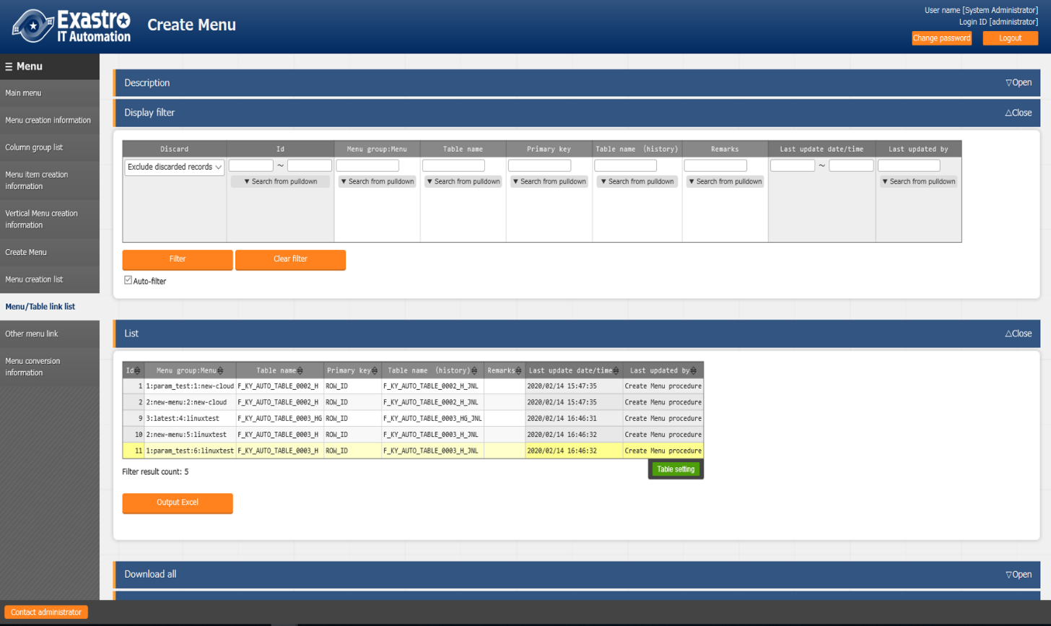

**Figure 8.2-1**

**Table 8.2-1**

|  |  |
| --- | --- |
| **Item name** | **Decription** |
| Menu group: Menu name | Menu name associated with DB. |
| Table name | Name of the created table. |
| Primary key | Primary key of the created table. |
| Table name(history) | The name of the created history table. |
| Remarks | Free description field |

## Other menu link

Displays the link between the created menu item name and the DB column name.

The menu is set hidden during installation. The menu is used by BackYard so no user operation can be performed. Even if you change the link directly after creating the menu, this menu will not change.

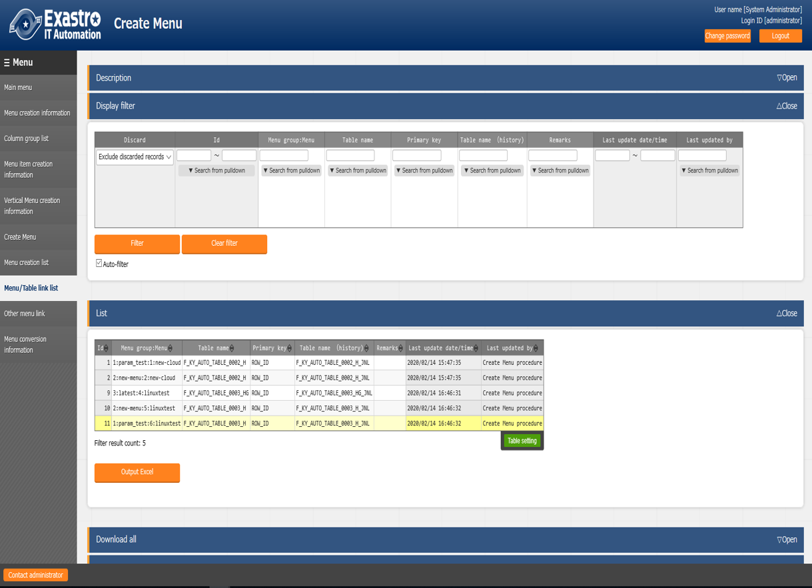

**Figure 8.3-1**

**Table 8.3-1**

|  |  |
| --- | --- |
| **Item name** | **Description** |
| Menu group | Menu group name associated with DB. |
| Menu | Menu name of created parameter sheet or data sheet |
| Item name | The column name that is associated. |
| Table name | Name of the created table. |
| Primary key | Primary key of the created table. |
| Column name | The column name that is linked. |
| Remarks | Free description field |

## Menu conversion information

Displays the link of the menu that is converted to horizontal from the created vertical menu.

The menu is set hidden during installation. The menu is used by BackYard so no user operation can be performed. Even if you change the link directly after creating the menu, this menu will not change.

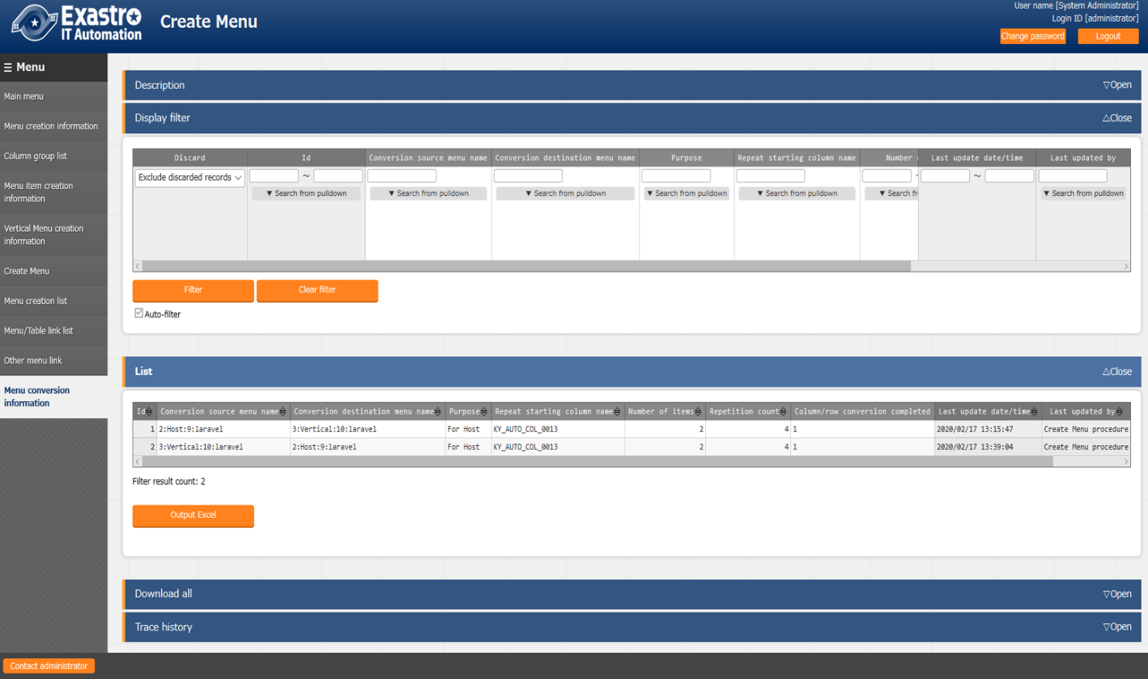

**Figure 8.4-1**

**Table 8.4-1**

|  |  |
| --- | --- |
| **Item name** | **Description** |
| Conversion source menu name | The vertical menu name of the source. |
| Conversion destination menu name | Horizontal menu name of the destination. |
| Use | The purpose of the sheet menu. |
| Repeat start column | The name of the repeat start item of the horizontal menu |
| Number of items | The number of items in the horizontal menu. |
| Number of repetitions | The number of repetitions of the horizontal menu. |
| Vertical and horizontal converted flag | Specify the vertical and horizontal converted flag. |
| Remarks | Free description field |

## Trace history when「Pulldown selection」is included in the sheet

This section describes how to display the history when items include 「Pulldown selection」 when creating a parameter sheet or data sheet.

When the parameter of the reference destination (hereinafter, master) is changed, the parameter referred to is also changed automatically.

「Trace history」 displays the value of the master when the parameter is edited (registered / updated / Discarded / restored)

Example:

In, Parameter sheet, Item of 「Param 1」 - 「Param 1-2」 refers to Item of 「Master」 - 「Master」.

Operation：

1. Register the value 「mas1-1」 in 「Master」
2. One entry is registered in 「Param1」.
3. Update the 「Param1」.
4. Update 「Master」 with value 「mas1-2」.
5. Update 「Master」 with value 「mas1-3」
6. Update the 「Param1」.
7. Update 「Master」 with value 「mas1-4」
8. Update 「Master」 with value 「mas1-5」
9. Update the 「Param1」

Display：

Display of 「Param1」

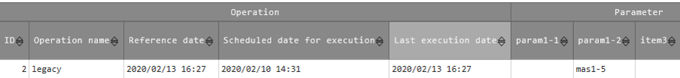

**Figure 8.5-1**

Trace history of 「Param1」

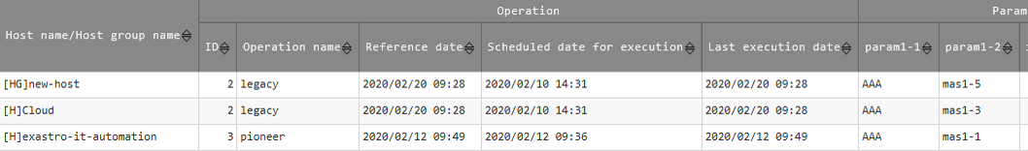

**⑤**

**⑧**

**①**

**Figure 8.5-2**

Display of 「master」

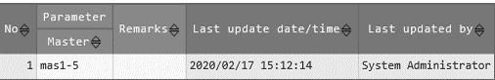

**Figure 8.5-3**

Trace history of 「master」

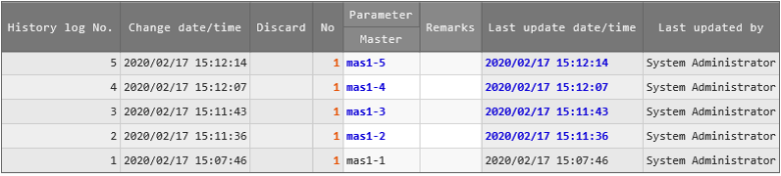

**⑨**

**④**

**⑤**

**⑦**

**Figure 8.5-4**